**Library Management APP Project**



[This Photo](https://betawiki.net/wiki/Main_Page) by Unknown Author is licensed under [CC BY-SA](https://creativecommons.org/licenses/by-sa/3.0/)

**Name: I.D.I.L Senavirathna**

**Registration Number: ICT/19/20/140**

**Index Number :5073**

**ICT3214 - Mobile Application Development**

1. **UI Design**

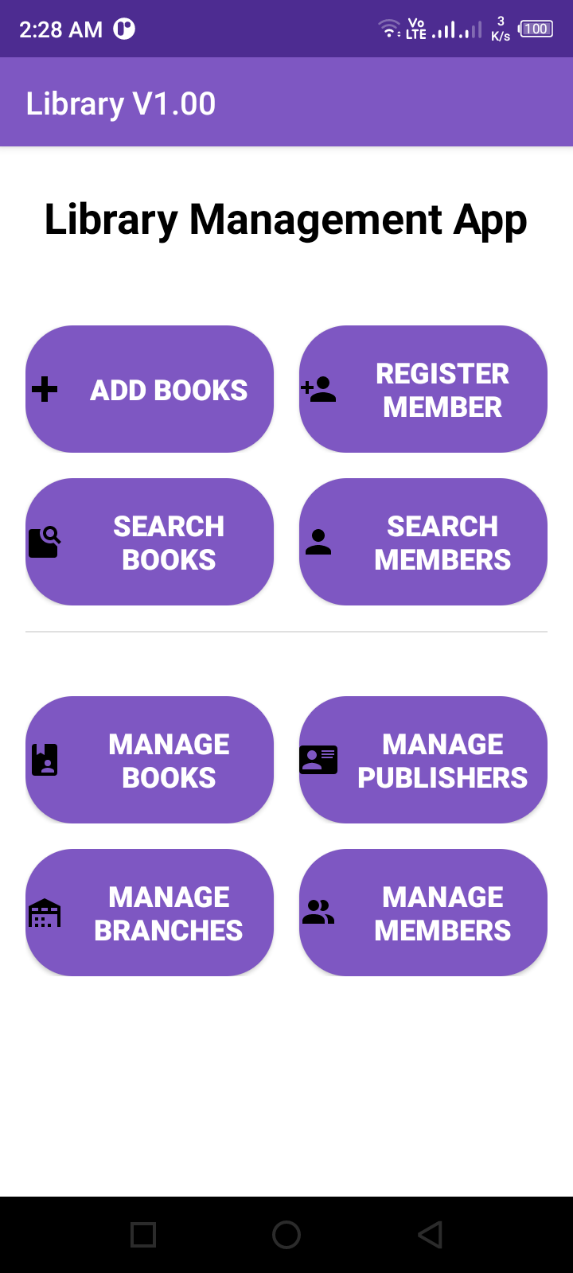

Buttons

1. **AndroidManifest.xml**

<?xml version="1.0" encoding="utf-8"?>  
<manifest xmlns:android="http://schemas.android.com/apk/res/android"  
 package="com.jovanovic.stefan.LibraryManagement">  
  
 <application  
 android:allowBackup="true"  
 android:icon="@mipmap/ic_launcher"  
 android:label="Library Management"  
 android:roundIcon="@mipmap/ic_launcher_round"  
 android:supportsRtl="true"  
 android:theme="@style/AppTheme">  
 <activity android:name="com.jovanovic.stefan.LibraryManagement.UpdateActivity"  
 android:parentActivityName="com.jovanovic.stefan.LibraryManagement.BookActivity"/>  
  
 <activity android:name="com.jovanovic.stefan.LibraryManagement.Publisher_UpdateActivity"  
 android:parentActivityName="com.jovanovic.stefan.LibraryManagement.PublisherActivity"/>  
  
 <activity android:name="com.jovanovic.stefan.LibraryManagement.Branch_UpdateActivity"  
 android:parentActivityName="com.jovanovic.stefan.LibraryManagement.BranchActivity"/>  
  
 <activity android:name="com.jovanovic.stefan.LibraryManagement.Member_UpdateActivity"  
 android:parentActivityName="com.jovanovic.stefan.LibraryManagement.MemberActivity"/>  
 <activity  
 android:name="com.jovanovic.stefan.LibraryManagement.AddActivity"  
 android:label="Add Book"  
 android:parentActivityName="com.jovanovic.stefan.LibraryManagement.BookActivity" />  
 <activity  
 android:name="com.jovanovic.stefan.LibraryManagement.Publisher_AddActivity"  
 android:label="Add Publisher"  
 android:parentActivityName="com.jovanovic.stefan.LibraryManagement.PublisherActivity" />  
 <activity  
 android:name="com.jovanovic.stefan.LibraryManagement.Branch_AddActivity"  
 android:label="Add Branch"  
 android:parentActivityName="com.jovanovic.stefan.LibraryManagement.BranchActivity" />  
 <activity  
 android:name="com.jovanovic.stefan.LibraryManagement.Member_AddActivity"  
 android:label="Add Member"  
 android:parentActivityName="com.jovanovic.stefan.LibraryManagement.MemberActivity" />  
 <activity  
 android:name="com.jovanovic.stefan.LibraryManagement.BookActivity"  
 android:label="Manage Books"  
 android:parentActivityName="com.jovanovic.stefan.LibraryManagement.MainActivity" />  
 <activity  
 android:name="com.jovanovic.stefan.LibraryManagement.PublisherActivity"  
 android:label="Manage Publishers"  
 android:parentActivityName="com.jovanovic.stefan.LibraryManagement.MainActivity" />  
 <activity  
 android:name="com.jovanovic.stefan.LibraryManagement.BranchActivity"  
 android:label="Manage Branch"  
 android:parentActivityName="com.jovanovic.stefan.LibraryManagement.MainActivity" />  
 <activity  
 android:name="com.jovanovic.stefan.LibraryManagement.MemberActivity"  
 android:label="Manage Member"  
 android:parentActivityName="com.jovanovic.stefan.LibraryManagement.MainActivity" />  
 <activity  
 android:name="com.jovanovic.stefan.LibraryManagement.SearchActivity"  
 android:label="Search Member"  
 android:parentActivityName="com.jovanovic.stefan.LibraryManagement.MainActivity" />  
 <activity  
 android:name="com.jovanovic.stefan.LibraryManagement.SearchBook"  
 android:label="Search Member"  
 android:parentActivityName="com.jovanovic.stefan.LibraryManagement.MainActivity" />  
 <activity  
 android:name="com.jovanovic.stefan.LibraryManagement.MainActivity"  
 android:label="Library V1.00">  
  
  
  
 <intent-filter>  
 <action android:name="android.intent.action.MAIN" />  
 <action android:name="android.intent.action.VIEW" />  
  
 <category android:name="android.intent.category.LAUNCHER" />  
 </intent-filter>  
 </activity>  
 </application>  
  
</manifest>

1. **MainActivity.java**

package com.jovanovic.stefan.LibraryManagement;  
  
import android.content.Intent;  
import android.os.Bundle;  
import android.view.View;  
import android.widget.Button;  
  
import androidx.appcompat.app.AppCompatActivity;  
  
public class MainActivity extends AppCompatActivity {  
 Button add_button,publishers_button,branch_button,member_button;  
 Button add_books,search_books,register_member,search_member;  
 MyDatabaseHelper myDB;  
  
 @Override  
 protected void onCreate(Bundle savedInstanceState) {  
 super.onCreate(savedInstanceState);  
 setContentView(R.layout.*activity_main*);  
  
  
 myDB = new MyDatabaseHelper(MainActivity.this);  
  
 ////////////////////////////////  
  
  
 ////////////////////////////////  
 add_button = findViewById(R.id.*button_books*);  
 publishers_button = findViewById(R.id.*button_publishers*);  
 branch_button = findViewById(R.id.*button_branches*);  
 member_button = findViewById(R.id.*button_members*);  
 add_books = findViewById(R.id.*add_books*);  
 search_books = findViewById(R.id.*search_books*);  
 register_member = findViewById(R.id.*register_member*);  
 search_member = findViewById(R.id.*search_member*);  
  
 add_button.setOnClickListener(new View.OnClickListener() {  
 @Override  
 public void onClick(View view) {  
  
  
 Intent intent = new Intent(MainActivity.this, BookActivity.class);  
 startActivity(intent);  
 }  
 });  
  
 publishers_button.setOnClickListener(new View.OnClickListener() {  
 @Override  
 public void onClick(View view) {  
 MyDatabaseHelper db = new MyDatabaseHelper(getApplicationContext());  
  
 Intent intent = new Intent(MainActivity.this, PublisherActivity.class);  
 startActivity(intent);  
 }  
 });  
  
 branch_button.setOnClickListener(new View.OnClickListener() {  
 @Override  
 public void onClick(View view) {  
 MyDatabaseHelper db = new MyDatabaseHelper(getApplicationContext());  
  
 Intent intent = new Intent(MainActivity.this, BranchActivity.class);  
 startActivity(intent);  
 }  
 });  
  
 member_button.setOnClickListener(new View.OnClickListener() {  
 @Override  
 public void onClick(View view) {  
 MyDatabaseHelper db = new MyDatabaseHelper(getApplicationContext());  
  
 Intent intent = new Intent(MainActivity.this, MemberActivity.class);  
 startActivity(intent);  
 }  
 });  
 add_books.setOnClickListener(new View.OnClickListener() {  
 @Override  
 public void onClick(View view) {  
 MyDatabaseHelper db = new MyDatabaseHelper(getApplicationContext());  
  
 Intent intent = new Intent(MainActivity.this, AddActivity.class);  
 startActivity(intent);  
 }  
 });  
 register_member.setOnClickListener(new View.OnClickListener() {  
 @Override  
 public void onClick(View view) {  
 MyDatabaseHelper db = new MyDatabaseHelper(getApplicationContext());  
  
 Intent intent = new Intent(MainActivity.this, Member_AddActivity.class);  
 startActivity(intent);  
 }  
 });  
 search_books.setOnClickListener(new View.OnClickListener() {  
 @Override  
 public void onClick(View view) {  
 MyDatabaseHelper db = new MyDatabaseHelper(getApplicationContext());  
  
 Intent intent = new Intent(MainActivity.this, SearchBook.class);  
 startActivity(intent);  
 }  
 });  
 search_member.setOnClickListener(new View.OnClickListener() {  
 @Override  
 public void onClick(View view) {  
 MyDatabaseHelper db = new MyDatabaseHelper(getApplicationContext());  
  
 Intent intent = new Intent(MainActivity.this, SearchActivity.class);  
 startActivity(intent);  
 }  
 });  
  
 }  
}

1. **MyDatabaseHelper.java**

package com.jovanovic.stefan.LibraryManagement;  
  
import static androidx.core.content.ContextCompat.*startActivity*;  
  
import android.content.ContentValues;  
import android.content.Context;  
import android.content.Intent;  
  
import android.database.Cursor;  
import android.database.sqlite.SQLiteDatabase;  
import android.database.sqlite.SQLiteOpenHelper;  
import android.widget.Toast;  
  
import androidx.annotation.NonNull;  
import androidx.annotation.Nullable;  
  
class MyDatabaseHelper extends SQLiteOpenHelper {  
  
 private Context context;  
 private static final String *DATABASE_NAME* = "BookLibrary.db";  
 private static final int *DATABASE_VERSION* = 1;  
 ///////////////////////////////////////////  
   
 MyDatabaseHelper(Context context) {  
 super(context, *DATABASE_NAME*, null, *DATABASE_VERSION*);  
 this.context = context;  
 }  
  
 @Override  
 public void onCreate(SQLiteDatabase db) {  
 String qr1 = "CREATE TABLE Book(\n" +  
 " BOOK_ID INTEGER PRIMARY KEY AUTOINCREMENT,\n" +  
 " TITLE TEXT,\n" +  
 " PUBLISHER_NAME TEXT,\n" +  
 " AVAILABLE INTEGER DEFAULT 1\n" +  
 ")";  
 db.execSQL(qr1);  
  
 // create Publisher table  
 String qr2 = "CREATE TABLE Publisher(\n" +  
 "NAME VARCHAR(20),\n" +  
 "ADDRESS VARCHAR(30),\n" +  
 "PHONE VARCHAR(10),\n" +  
 "PRIMARY KEY (NAME));\n";  
 db.execSQL(qr2);  
  
 // create Branch table  
 String qr3 = "CREATE TABLE Branch(\n" +  
 "BRANCH_ID INTEGER PRIMARY KEY AUTOINCREMENT,\n" +  
 "BRANCH_NAME TEXT,\n" +  
 "BRANCH_ADDRESS TEXT);\n";  
 db.execSQL(qr3);  
  
 // create Member table  
 String qr4 = "CREATE TABLE Member(\n" +  
 "CARD_NO INTEGER PRIMARY KEY AUTOINCREMENT,\n" +  
 "NAME TEXT,\n" +  
 "ADDRESS TEXT,\n" +  
 "PHONE TEXT,\n" +  
 "UNPAID_DUES REAL DEFAULT 0);\n";  
 db.execSQL(qr4);  
  
 // create Book_Author table  
 String qr5 = "CREATE TABLE Book_Author(\n" +  
 "BOOK_ID INTEGER,\n" +  
 "AUTHOR_NAME TEXT,\n" +  
 "PRIMARY KEY(BOOK_ID, AUTHOR_NAME),\n" +  
 "FOREIGN KEY(BOOK_ID) REFERENCES Book);\n";  
 db.execSQL(qr5);  
  
 // create Book_Copy table  
 String qr6 = "CREATE TABLE Book_Copy(\n" +  
 "BOOK_ID INTEGER,\n" +  
 "BRANCH_ID INTEGER,\n" +  
 "ACCESS_NO INTEGER PRIMARY KEY AUTOINCREMENT,\n" +  
 "FOREIGN KEY(BOOK_ID) REFERENCES Book(BOOK_ID),\n" +  
 "FOREIGN KEY(BRANCH_ID) REFERENCES Branch(BRANCH_ID));\n";  
 db.execSQL(qr6);  
  
 // create Book_Loan table  
 String qr7 = "CREATE TABLE Book_Loan(\n" +  
 "ACCESS_NO INTEGER PRIMARY KEY AUTOINCREMENT,\n" +  
 "BRANCH_ID INTEGER,\n" +  
 "CARD_NO INTEGER,\n" +  
 "DATE_OUT TEXT,\n" +  
 "DATE_DUE TEXT,\n" +  
 "DATE_RETURNED TEXT,\n" +  
 "FOREIGN KEY(ACCESS_NO, BRANCH_ID) REFERENCES Book_Copy,\n" +  
 "FOREIGN KEY(CARD_NO) REFERENCES Member,\n" +  
 "FOREIGN KEY(BRANCH_ID) REFERENCES Branch);\n";  
 db.execSQL(qr7);  
  
  
}  
  
 @Override  
 public void onUpgrade(SQLiteDatabase db, int i, int i1) {  
 db.execSQL("DROP TABLE IF EXISTS " + "Book" );  
 onCreate(db);  
 }  
 public void sample() {  
 SQLiteDatabase db = this.getWritableDatabase();  
  
  
 }  
  
 void addBook(String title, String publisher_name,String available){  
 SQLiteDatabase db = this.getWritableDatabase();  
 ContentValues cv = new ContentValues();  
  
 cv.put("TITLE", title);  
 cv.put("PUBLISHER_NAME", publisher_name);  
 cv.put("AVAILABLE", available);  
  
 long result = db.insert("Book",null, cv);  
 if(result == -1){  
 Toast.*makeText*(context, "Failed", Toast.*LENGTH_SHORT*).show();  
 }else {  
 Toast.*makeText*(context, "Added Successfully!", Toast.*LENGTH_SHORT*).show();  
  
  
 }  
 }  
  
 void addPublisher(String publisher_name,String publisher_address,String publisher_phone){  
 SQLiteDatabase db = this.getWritableDatabase();  
 ContentValues cv = new ContentValues();  
  
 cv.put("NAME", publisher_name);  
 cv.put("ADDRESS", publisher_address);  
 cv.put("PHONE", publisher_phone);  
  
 long result = db.insert("Publisher",null, cv);  
 if(result == -1){  
 Toast.*makeText*(context, "Failed", Toast.*LENGTH_SHORT*).show();  
 }else {  
 Toast.*makeText*(context, "Added Successfully!", Toast.*LENGTH_SHORT*).show();  
  
  
 }  
 }  
 void addBranch(String branch_name,String branch_address){  
 SQLiteDatabase db = this.getWritableDatabase();  
 ContentValues cv = new ContentValues();  
  
  
 cv.put("BRANCH_NAME", branch_name);  
 cv.put("BRANCH_ADDRESS", branch_address);  
  
 long result = db.insert("Branch",null, cv);  
 if(result == -1){  
 Toast.*makeText*(context, "Failed", Toast.*LENGTH_SHORT*).show();  
 }else {  
 Toast.*makeText*(context, "Added Successfully!", Toast.*LENGTH_SHORT*).show();  
  
  
 }  
 }  
 void addMember(String NAME,String ADDRESS,String PHONE,Double UNPAID_DUES){  
 SQLiteDatabase db = this.getWritableDatabase();  
 ContentValues cv = new ContentValues();  
  
  
 cv.put("NAME", NAME);  
 cv.put("ADDRESS", ADDRESS);  
 cv.put("PHONE", PHONE);  
 cv.put("UNPAID_DUES", UNPAID_DUES);  
  
 long result = db.insert("Member",null, cv);  
 if(result == -1){  
 Toast.*makeText*(context, "Failed", Toast.*LENGTH_SHORT*).show();  
 }else {  
 Toast.*makeText*(context, "Added Successfully!", Toast.*LENGTH_SHORT*).show();  
  
  
 }  
 }  
 void copyBook(String title, String publisher_name,String available){  
 SQLiteDatabase db = this.getWritableDatabase();  
 ContentValues cv = new ContentValues();  
  
 cv.put("TITLE", title);  
 cv.put("PUBLISHER_NAME", publisher_name);  
 cv.put("AVAILABLE", available);  
  
 long result = db.insert("Book",null, cv);  
 if(result == -1){  
 Toast.*makeText*(context, "Failed", Toast.*LENGTH_SHORT*).show();  
 }else {  
 Toast.*makeText*(context, "Added Successfully!", Toast.*LENGTH_SHORT*).show();  
  
  
 }  
 }  
  
 Cursor readAllData(){  
 String query = "SELECT * FROM " + "Book";  
 SQLiteDatabase db = this.getReadableDatabase();  
  
 Cursor cursor = null;  
 if(db != null){  
 cursor = db.rawQuery(query, null);  
 }  
 return cursor;  
 }  
 Cursor readAllData_publisher(){  
 String query = "SELECT * FROM " + "Publisher";  
 SQLiteDatabase db = this.getReadableDatabase();  
  
 Cursor cursor = null;  
 if(db != null){  
 cursor = db.rawQuery(query, null);  
 }  
 return cursor;  
 }  
 Cursor readAllData_branch(){  
 String query = "SELECT * FROM " + "Branch";  
 SQLiteDatabase db = this.getReadableDatabase();  
  
 Cursor cursor = null;  
 if(db != null){  
 cursor = db.rawQuery(query, null);  
 }  
 return cursor;  
 }  
 Cursor readAllData_member(){  
 String query = "SELECT * FROM " + "Member";  
 SQLiteDatabase db = this.getReadableDatabase();  
  
 Cursor cursor = null;  
 if(db != null){  
 cursor = db.rawQuery(query, null);  
 }  
 return cursor;  
 }  
  
 void updateData(String row_id, String title, String publisher_name,String AVAILABLE){  
 SQLiteDatabase db = this.getWritableDatabase();  
 ContentValues cv = new ContentValues();  
 cv.put("TITLE", title);  
 cv.put("PUBLISHER_NAME", publisher_name);  
 cv.put("AVAILABLE", AVAILABLE);  
  
 long result = db.update("Book", cv, "BOOK_ID=?", new String[]{row_id});  
 if(result == -1){  
 Toast.*makeText*(context, "Failed", Toast.*LENGTH_SHORT*).show();  
 }else {  
 Toast.*makeText*(context, "Updated Successfully!", Toast.*LENGTH_SHORT*).show();  
 }  
  
 }  
 void updateData_publisher(String row_name, String address, String phone){  
 SQLiteDatabase db = this.getWritableDatabase();  
 ContentValues cv = new ContentValues();  
 cv.put("NAME", row_name);  
 cv.put("ADDRESS", address);  
 cv.put("PHONE", phone);  
  
  
 long result = db.update("Publisher", cv, "NAME=?", new String[]{row_name});  
 if(result == -1){  
 Toast.*makeText*(context, "Failed", Toast.*LENGTH_SHORT*).show();  
 }else {  
 Toast.*makeText*(context, "Updated Successfully!", Toast.*LENGTH_SHORT*).show();  
 }  
  
 }  
 void updateData_branch(String row_id, String name, String address){  
 SQLiteDatabase db = this.getWritableDatabase();  
 ContentValues cv = new ContentValues();  
 cv.put("BRANCH_NAME", name);  
 cv.put("BRANCH_ADDRESS", address);  
  
  
  
 long result = db.update("Branch", cv, "BRANCH_ID=?", new String[]{row_id});  
 if(result == -1){  
 Toast.*makeText*(context, "Failed", Toast.*LENGTH_SHORT*).show();  
 }else {  
 Toast.*makeText*(context, "Updated Successfully!", Toast.*LENGTH_SHORT*).show();  
 }  
  
 }  
 void updateData_member(String row_id,String name, String address, String phone,String UNPAID_DUES){  
 SQLiteDatabase db = this.getWritableDatabase();  
 ContentValues cv = new ContentValues();  
 cv.put("NAME", name);  
 cv.put("ADDRESS", address);  
 cv.put("PHONE", phone);  
 cv.put("UNPAID_DUES", UNPAID_DUES);  
  
  
 long result = db.update("Member", cv, "CARD_NO=?", new String[]{row_id});  
 if(result == -1){  
 Toast.*makeText*(context, "Failed", Toast.*LENGTH_SHORT*).show();  
 }else {  
 Toast.*makeText*(context, "Updated Successfully!", Toast.*LENGTH_SHORT*).show();  
 }  
  
 }  
 void deleteOneRow(String row_id){  
 SQLiteDatabase db = this.getWritableDatabase();  
 long result = db.delete("Book", "book_id=?", new String[]{row_id});  
 if(result == -1){  
 Toast.*makeText*(context, "Failed to Delete.", Toast.*LENGTH_SHORT*).show();  
 }else{  
 Toast.*makeText*(context, "Successfully Deleted.", Toast.*LENGTH_SHORT*).show();  
 }  
 }  
 void deleteOneRow_publisher(String row_name){  
 SQLiteDatabase db = this.getWritableDatabase();  
 long result = db.delete("Publisher", "NAME=?", new String[]{row_name});  
 if(result == -1){  
 Toast.*makeText*(context, "Failed to Delete.", Toast.*LENGTH_SHORT*).show();  
 }else{  
 Toast.*makeText*(context, "Successfully Deleted.", Toast.*LENGTH_SHORT*).show();  
 }  
 }  
 void deleteOneRow_branch(String row_name){  
 SQLiteDatabase db = this.getWritableDatabase();  
 long result = db.delete("Branch", "BRANCH_ID=?", new String[]{row_name});  
 if(result == -1){  
 Toast.*makeText*(context, "Failed to Delete.", Toast.*LENGTH_SHORT*).show();  
 }else{  
 Toast.*makeText*(context, "Successfully Deleted.", Toast.*LENGTH_SHORT*).show();  
 }  
 }  
 void deleteOneRow_member(String row_name){  
 SQLiteDatabase db = this.getWritableDatabase();  
 long result = db.delete("Member", "CARD_NO=?", new String[]{row_name});  
 if(result == -1){  
 Toast.*makeText*(context, "Failed to Delete.", Toast.*LENGTH_SHORT*).show();  
 }else{  
 Toast.*makeText*(context, "Successfully Deleted.", Toast.*LENGTH_SHORT*).show();  
 }  
 }  
 void deleteAllData(){  
 SQLiteDatabase db = this.getWritableDatabase();  
 db.execSQL("DELETE FROM " + "Book");  
 }  
 void deleteAllData_publisher(){  
 SQLiteDatabase db = this.getWritableDatabase();  
 db.execSQL("DELETE FROM " + "Publisher");  
 }  
 void deleteAllData_branch(){  
 SQLiteDatabase db = this.getWritableDatabase();  
 db.execSQL("DELETE FROM " + "Branch");  
 }  
 void deleteAllData_member(){  
 SQLiteDatabase db = this.getWritableDatabase();  
 db.execSQL("DELETE FROM " + "Member");  
 }  
  
}

1. **CustomAdapter.java**

package com.jovanovic.stefan.LibraryManagement;  
  
import android.app.Activity;  
import android.content.Context;  
import android.content.Intent;  
import android.os.Build;  
import android.view.LayoutInflater;  
import android.view.View;  
import android.view.ViewGroup;  
import android.view.animation.Animation;  
import android.view.animation.AnimationUtils;  
import android.widget.LinearLayout;  
import android.widget.TextView;  
  
import androidx.annotation.NonNull;  
import androidx.annotation.RequiresApi;  
import androidx.recyclerview.widget.RecyclerView;  
  
import java.util.ArrayList;  
  
public class CustomAdapter extends RecyclerView.Adapter<CustomAdapter.MyViewHolder> {  
  
 private Context context;  
 private Activity activity;  
 private ArrayList book_id, book_title, publisher_name, book_available;  
  
 CustomAdapter(Activity activity, Context context, ArrayList book_id, ArrayList book_title, ArrayList publisher_name  
 , ArrayList book_available){  
 this.activity = activity;  
 this.context = context;  
 this.book_id = book_id;  
 this.book_title = book_title;  
 this.publisher_name = publisher_name;  
 this.book_available = book_available;  
  
 }  
  
 @NonNull  
 @Override  
 public MyViewHolder onCreateViewHolder(@NonNull ViewGroup parent, int viewType) {  
 LayoutInflater inflater = LayoutInflater.*from*(context);  
 View view = inflater.inflate(R.layout.*my_row*, parent, false);  
 return new MyViewHolder(view);  
 }  
  
 @RequiresApi(api = Build.VERSION_CODES.*M*)  
 @Override  
 public void onBindViewHolder(@NonNull final MyViewHolder holder, final int position) {  
 holder.book_id_txt.setText(String.*valueOf*(book_id.get(position)));  
 holder.book_title_txt.setText(String.*valueOf*(book_title.get(position)));  
 holder.publisher_name_txt.setText(String.*valueOf*(publisher_name.get(position)));  
 holder.book_available_txt.setText(String.*valueOf*(book_available.get(position)));  
  
 //Recyclerview onClickListener  
 holder.mainLayout.setOnClickListener(new View.OnClickListener() {  
 @Override  
 public void onClick(View view) {  
 Intent intent = new Intent(context, UpdateActivity.class);  
 intent.putExtra("BOOK_ID", String.*valueOf*(book_id.get(position)));  
 intent.putExtra("TITLE", String.*valueOf*(book_title.get(position)));  
 intent.putExtra("PUBLISHER_NAME", String.*valueOf*(publisher_name.get(position)));  
 intent.putExtra("AVAILABLE", String.*valueOf*(book_available.get(position)));  
 activity.startActivityForResult(intent, 1);  
 }  
 });  
  
  
 }  
  
 @Override  
 public int getItemCount() {  
 return book_id.size();  
 }  
  
 class MyViewHolder extends RecyclerView.ViewHolder {  
  
 TextView book_id_txt, book_title_txt, publisher_name_txt,book_available_txt;  
 LinearLayout mainLayout;  
  
 MyViewHolder(@NonNull View itemView) {  
 super(itemView);  
 book_id_txt = itemView.findViewById(R.id.*book_id_txt*);  
 book_title_txt = itemView.findViewById(R.id.*book_title_txt*);  
 publisher_name_txt = itemView.findViewById(R.id.*publisher_name_txt*);  
 book_available_txt = itemView.findViewById(R.id.*book_available_txt*);  
  
 mainLayout = itemView.findViewById(R.id.*mainLayout*);  
 //Animate Recyclerview  
 Animation translate_anim = AnimationUtils.*loadAnimation*(context, R.anim.*translate_anim*);  
 mainLayout.setAnimation(translate_anim);  
 }  
  
 }  
  
}

1. **AddActivity.java**

package com.jovanovic.stefan.LibraryManagement;  
  
import androidx.appcompat.app.AppCompatActivity;  
  
import android.os.Bundle;  
import android.view.View;  
import android.widget.Button;  
import android.widget.EditText;  
  
public class AddActivity extends AppCompatActivity {  
  
 EditText title_input, publisher_name,book_available;  
 Button add_button;  
  
 @Override  
 protected void onCreate(Bundle savedInstanceState) {  
 super.onCreate(savedInstanceState);  
 setContentView(R.layout.*activity_add*);  
  
 title_input = findViewById(R.id.*title_input*);  
 publisher_name = findViewById(R.id.*author_input*);  
 book_available = findViewById(R.id.*book_available_input*);  
 add_button = findViewById(R.id.*add_button*);  
  
  
 add_button.setOnClickListener(new View.OnClickListener() {  
 @Override  
 public void onClick(View view) {  
 MyDatabaseHelper myDB = new MyDatabaseHelper(AddActivity.this);  
 myDB.addBook(title_input.getText().toString().trim(),  
 publisher_name.getText().toString().trim(),  
 book_available.getText().toString().trim());  
 }  
 });  
  
 }  
}

1. **BookActivity.java**

package com.jovanovic.stefan.LibraryManagement;  
  
import android.content.DialogInterface;  
import android.content.Intent;  
import android.database.Cursor;  
import android.database.sqlite.SQLiteDatabase;  
import android.os.Bundle;  
import android.view.Menu;  
import android.view.MenuInflater;  
import android.view.MenuItem;  
import android.view.View;  
import android.widget.ImageView;  
import android.widget.TextView;  
  
import androidx.annotation.Nullable;  
import androidx.appcompat.app.AlertDialog;  
import androidx.appcompat.app.AppCompatActivity;  
import androidx.recyclerview.widget.LinearLayoutManager;  
import androidx.recyclerview.widget.RecyclerView;  
  
import com.google.android.material.floatingactionbutton.FloatingActionButton;  
  
import java.util.ArrayList;  
  
public class BookActivity extends AppCompatActivity {  
  
 RecyclerView recyclerView;  
 FloatingActionButton add_button;  
 ImageView empty_imageview;  
 TextView no_data;  
  
 MyDatabaseHelper myDB;  
 ArrayList<String> book_id, book_title, publisher_name,book_available;  
 CustomAdapter customAdapter;  
  
 @Override  
 protected void onCreate(Bundle savedInstanceState) {  
 super.onCreate(savedInstanceState);  
 setContentView(R.layout.activity_book);  
  
 recyclerView = findViewById(R.id.recyclerView);  
 add_button = findViewById(R.id.add_button);  
 empty_imageview = findViewById(R.id.empty_imageview);  
 no_data = findViewById(R.id.no_data);  
 add_button.setOnClickListener(new View.OnClickListener() {  
 @Override  
 public void onClick(View view) {  
 Intent intent = new Intent(BookActivity.this, AddActivity.class);  
 startActivity(intent);  
 }  
 });  
  
 myDB = new MyDatabaseHelper(BookActivity.this);  
  
 book_id = new ArrayList<>();  
 book_title = new ArrayList<>();  
 publisher_name = new ArrayList<>();  
 book_available = new ArrayList<>();  
  
  
  
 customAdapter = new CustomAdapter(BookActivity.this,this, book_id, book_title, publisher_name,book_available);  
 //customAdapter = new CustomAdapter(BookActivity.this,this, "1", book_title, publisher_name);  
 recyclerView.setAdapter(customAdapter);  
 recyclerView.setLayoutManager(new LinearLayoutManager(BookActivity.this));  
 storeDataInArrays();  
 }  
  
 @Override  
 protected void onActivityResult(int requestCode, int resultCode, @Nullable Intent data) {  
 super.onActivityResult(requestCode, resultCode, data);  
 if(requestCode == 1){  
 recreate();  
 }  
 }  
  
  
 void storeDataInArrays(){  
 Cursor cursor = myDB.readAllData();  
 if(cursor.getCount() == 0){  
 empty_imageview.setVisibility(View.VISIBLE);  
 no_data.setVisibility(View.VISIBLE);  
 }else{  
 while (cursor.moveToNext()){  
 book_id.add(cursor.getString(0));  
 book_title.add(cursor.getString(1));  
 publisher_name.add(cursor.getString(2));  
 book_available.add(cursor.getString(3));  
  
 }  
 empty_imageview.setVisibility(View.GONE);  
 no_data.setVisibility(View.GONE);  
 }  
 }  
  
 @Override  
 public boolean onCreateOptionsMenu(Menu menu) {  
 MenuInflater inflater = getMenuInflater();  
 inflater.inflate(R.menu.my_menu, menu);  
 return super.onCreateOptionsMenu(menu);  
 }  
  
 @Override  
 public boolean onOptionsItemSelected(MenuItem item) {  
 if(item.getItemId() == R.id.delete_all){  
 confirmDialog();  
 }  
 return super.onOptionsItemSelected(item);  
 }  
  
 void confirmDialog(){  
 AlertDialog.Builder builder = new AlertDialog.Builder(this);  
 builder.setTitle("Delete All?");  
 builder.setMessage("Are you sure you want to delete all Data?");  
 builder.setPositiveButton("Yes", new DialogInterface.OnClickListener() {  
 @Override  
 public void onClick(DialogInterface dialogInterface, int i) {  
 MyDatabaseHelper myDB = new MyDatabaseHelper(BookActivity.this);  
 myDB.deleteAllData();  
 //Refresh Activity  
 Intent intent = new Intent(BookActivity.this, BookActivity.class);  
 startActivity(intent);  
 finish();  
 }  
 });  
 builder.setNegativeButton("No", new DialogInterface.OnClickListener() {  
 @Override  
 public void onClick(DialogInterface dialogInterface, int i) {  
  
 }  
 });  
 builder.create().show();  
 }  
}

1. **SearchActivity.java**

package com.jovanovic.stefan.LibraryManagement;  
  
import androidx.appcompat.app.AppCompatActivity;  
import android.app.Activity;  
import android.content.Context;  
import android.database.Cursor;  
import android.database.sqlite.SQLiteDatabase;  
import android.os.Bundle;  
import android.text.Editable;  
import android.text.TextWatcher;  
import android.view.View;  
import android.widget.ArrayAdapter;  
import android.widget.EditText;  
import android.widget.ListView;  
import android.widget.Toast;  
  
import java.util.ArrayList;  
public class SearchActivity extends AppCompatActivity {  
  
 EditText searchEditText;  
 ListView listView;  
 ArrayAdapter<String> adapter;  
 SQLiteDatabase sqLiteDatabase;  
 ArrayList<String> memberList = new ArrayList<>();  
  
 @Override  
 protected void onCreate(Bundle savedInstanceState) {  
 super.onCreate(savedInstanceState);  
 setContentView(R.layout.*activity_search*);  
  
 searchEditText = findViewById(R.id.*searchEditText*);  
 listView = findViewById(R.id.*listView*);  
 adapter = new ArrayAdapter<>(this, android.R.layout.*simple_list_item_1*, memberList);  
 listView.setAdapter(adapter);  
  
 // Initialize SQLite Database  
 sqLiteDatabase = openOrCreateDatabase("BookLibrary.db", Context.*MODE_PRIVATE*, null);  
  
 // Call method to fetch all members from the database  
 fetchAllMembers();  
  
 // TextWatcher to listen to changes in the searchEditText  
 searchEditText.addTextChangedListener(new TextWatcher() {  
 @Override  
 public void beforeTextChanged(CharSequence charSequence, int i, int i1, int i2) {}  
  
 @Override  
 public void onTextChanged(CharSequence charSequence, int i, int i1, int i2) {}  
  
 @Override  
 public void afterTextChanged(Editable editable) {  
 // Filter members based on the text entered in the searchEditText  
 filterMembers(editable.toString());  
 }  
 });  
 }  
  
 // Method to fetch all members from the database  
 private void fetchAllMembers() {  
 Cursor cursor = sqLiteDatabase.rawQuery("SELECT * FROM Member", null);  
 if (cursor.moveToFirst()) {  
 do {  
 String memberName = cursor.getString(cursor.getColumnIndex("NAME"));  
 memberList.add(memberName);  
 } while (cursor.moveToNext());  
 adapter.notifyDataSetChanged();  
 }  
 cursor.close();  
 }  
  
 // Method to filter members based on the search query  
 private void filterMembers(String query) {  
 ArrayList<String> filteredList = new ArrayList<>();  
 for (String member : memberList) {  
 if (member.toLowerCase().contains(query.toLowerCase())) {  
 filteredList.add(member);  
 }  
 }  
 adapter = new ArrayAdapter<>(this, android.R.layout.*simple_list_item_1*, filteredList);  
 listView.setAdapter(adapter);  
 }  
  
}

1. **SearchBook.java**

package com.jovanovic.stefan.LibraryManagement;  
import android.app.Activity;  
import android.content.Context;  
import android.database.Cursor;  
import android.database.sqlite.SQLiteDatabase;  
import android.os.Bundle;  
import android.text.Editable;  
import android.text.TextWatcher;  
import android.view.View;  
import android.widget.ArrayAdapter;  
import android.widget.EditText;  
import android.widget.ListView;  
import android.widget.Toast;  
  
import java.util.ArrayList;  
import androidx.appcompat.app.AppCompatActivity;  
  
public class SearchBook extends AppCompatActivity {  
  
 EditText searchEditText;  
 ListView listView;  
 ArrayAdapter<String> adapter;  
 SQLiteDatabase sqLiteDatabase;  
 ArrayList<String> bookList = new ArrayList<>();  
  
 @Override  
 protected void onCreate(Bundle savedInstanceState) {  
 super.onCreate(savedInstanceState);  
 setContentView(R.layout.*activity_searchbook*);  
  
 searchEditText = findViewById(R.id.*searchEditText1*);  
 listView = findViewById(R.id.*listView1*);  
 adapter = new ArrayAdapter<>(this, android.R.layout.*simple_list_item_1*, bookList);  
 listView.setAdapter(adapter);  
  
 // Initialize SQLite Database  
 sqLiteDatabase = openOrCreateDatabase("BookLibrary.db", Context.*MODE_PRIVATE*, null);  
  
 // Call method to fetch all books from the database  
 fetchAllBooks();  
  
 // TextWatcher to listen to changes in the searchEditText  
 searchEditText.addTextChangedListener(new TextWatcher() {  
 @Override  
 public void beforeTextChanged(CharSequence charSequence, int i, int i1, int i2) {}  
  
 @Override  
 public void onTextChanged(CharSequence charSequence, int i, int i1, int i2) {}  
  
 @Override  
 public void afterTextChanged(Editable editable) {  
 // Filter books based on the text entered in the searchEditText  
 filterBooks(editable.toString());  
 }  
 });  
 }  
  
 // Method to fetch all books from the database  
 private void fetchAllBooks() {  
 Cursor cursor = sqLiteDatabase.rawQuery("SELECT * FROM Book", null);  
 if (cursor.moveToFirst()) {  
 do {  
 String bookTitle = cursor.getString(cursor.getColumnIndex("TITLE"));  
 bookList.add(bookTitle);  
 } while (cursor.moveToNext());  
 adapter.notifyDataSetChanged();  
 }  
 cursor.close();  
 }  
  
 // Method to filter books based on the search query  
 private void filterBooks(String query) {  
 ArrayList<String> filteredList = new ArrayList<>();  
 for (String book : bookList) {  
 if (book.toLowerCase().contains(query.toLowerCase())) {  
 filteredList.add(book);  
 }  
 }  
 adapter = new ArrayAdapter<>(this, android.R.layout.*simple_list_item_1*, filteredList);  
 listView.setAdapter(adapter);  
 }  
}

1. **UpdateActivity.java**

package com.jovanovic.stefan.LibraryManagement;  
  
import androidx.appcompat.app.ActionBar;  
import androidx.appcompat.app.AlertDialog;  
import androidx.appcompat.app.AppCompatActivity;  
  
import android.content.DialogInterface;  
import android.os.Bundle;  
import android.util.Log;  
import android.view.View;  
import android.widget.Button;  
import android.widget.EditText;  
import android.widget.Toast;  
  
public class UpdateActivity extends AppCompatActivity {  
  
 EditText title_input, publisher_name_input,book_available_input2;  
 Button update_button, copy_book,delete_button;  
  
 String book_id, title, publisher_name,book_available;  
  
 @Override  
 protected void onCreate(Bundle savedInstanceState) {  
 super.onCreate(savedInstanceState);  
 setContentView(R.layout.*activity_update*);  
  
 title_input = findViewById(R.id.*title_input2*);  
 publisher_name_input = findViewById(R.id.*publisher_name_input2*);  
 book_available_input2 = findViewById(R.id.*book_available_input2*);  
  
 update_button = findViewById(R.id.*update_button*);  
 copy_book = findViewById(R.id.*copy_book*);  
 delete_button = findViewById(R.id.*delete_button*);  
  
 //First we call this  
 getAndSetIntentData();  
  
 //Set actionbar title after getAndSetIntentData method  
 ActionBar ab = getSupportActionBar();  
 if (ab != null) {  
 ab.setTitle(title);  
 }  
  
 update_button.setOnClickListener(new View.OnClickListener() {  
 @Override  
 public void onClick(View view) {  
 //And only then we call this  
 MyDatabaseHelper myDB = new MyDatabaseHelper(UpdateActivity.this);  
 title = title_input.getText().toString().trim();  
 publisher_name = publisher_name_input.getText().toString().trim();  
 book_available = book_available_input2.getText().toString().trim();  
 myDB.updateData(book_id, title, publisher_name, book_available);  
 }  
 });  
 copy_book.setOnClickListener(new View.OnClickListener() {  
 @Override  
 public void onClick(View view) {  
 //And only then we call this  
 MyDatabaseHelper myDB = new MyDatabaseHelper(UpdateActivity.this);  
 title = title_input.getText().toString().trim();  
 publisher_name = publisher_name_input.getText().toString().trim();  
 book_available = book_available_input2.getText().toString().trim();  
 myDB.copyBook(title,publisher_name,book_available);  
 }  
 });  
 delete_button.setOnClickListener(new View.OnClickListener() {  
 @Override  
 public void onClick(View view) {  
 confirmDialog();  
 }  
 });  
  
 }  
  
 void getAndSetIntentData(){  
 if(getIntent().hasExtra("BOOK_ID") && getIntent().hasExtra("TITLE") &&  
 getIntent().hasExtra("PUBLISHER_NAME") &&  
 getIntent().hasExtra("AVAILABLE")){  
 //Getting Data from Intent  
 book_id = getIntent().getStringExtra("BOOK_ID");  
 title = getIntent().getStringExtra("TITLE");  
 publisher_name = getIntent().getStringExtra("PUBLISHER_NAME");  
 book_available = getIntent().getStringExtra("AVAILABLE");  
  
 //Setting Intent Data  
 title_input.setText(title);  
 publisher_name_input.setText( publisher_name);  
 book_available_input2.setText( book_available);  
 Log.*d*("stev", title+" "+ publisher_name+""+book_available);  
 }else{  
 Toast.*makeText*(this, "No data.", Toast.*LENGTH_SHORT*).show();  
 }  
 }  
  
 void confirmDialog(){  
 AlertDialog.Builder builder = new AlertDialog.Builder(this);  
 builder.setTitle("Delete " + title + " ?");  
 builder.setMessage("Are you sure you want to delete " + title + " ?");  
 builder.setPositiveButton("Yes", new DialogInterface.OnClickListener() {  
 @Override  
 public void onClick(DialogInterface dialogInterface, int i) {  
 MyDatabaseHelper myDB = new MyDatabaseHelper(UpdateActivity.this);  
 myDB.deleteOneRow(book_id);  
 finish();  
 }  
 });  
 builder.setNegativeButton("No", new DialogInterface.OnClickListener() {  
 @Override  
 public void onClick(DialogInterface dialogInterface, int i) {  
  
 }  
 });  
 builder.create().show();  
 }  
}

1. **Branch_AddActivity.java**

package com.jovanovic.stefan.LibraryManagement;  
  
import android.content.DialogInterface;  
import android.content.Intent;  
import android.database.Cursor;  
import android.os.Bundle;  
import android.view.Menu;  
import android.view.MenuInflater;  
import android.view.MenuItem;  
import android.view.View;  
import android.widget.ImageView;  
import android.widget.TextView;  
  
import androidx.annotation.Nullable;  
import androidx.appcompat.app.AlertDialog;  
import androidx.appcompat.app.AppCompatActivity;  
import androidx.recyclerview.widget.LinearLayoutManager;  
import androidx.recyclerview.widget.RecyclerView;  
  
import com.google.android.material.floatingactionbutton.FloatingActionButton;  
  
import java.util.ArrayList;  
  
public class BranchActivity extends AppCompatActivity {  
  
 RecyclerView recyclerView;  
 FloatingActionButton add_button;  
 ImageView empty_imageview;  
 TextView no_data;  
  
 MyDatabaseHelper myDB;  
 ArrayList<String> branch_id,branch_name, branch_address;  
 Branch_CustomAdapter customAdapter;  
  
 @Override  
 protected void onCreate(Bundle savedInstanceState) {  
 super.onCreate(savedInstanceState);  
 setContentView(R.layout.*activity_branch*);  
  
 recyclerView = findViewById(R.id.*recyclerView*);  
 add_button = findViewById(R.id.*add_button*);  
 empty_imageview = findViewById(R.id.*empty_imageview*);  
 no_data = findViewById(R.id.*no_data*);  
 add_button.setOnClickListener(new View.OnClickListener() {  
 @Override  
 public void onClick(View view) {  
 Intent intent = new Intent(BranchActivity.this, Branch_AddActivity.class);  
 startActivity(intent);  
 }  
 });  
  
 myDB = new MyDatabaseHelper(BranchActivity.this);  
 branch_name = new ArrayList<>();  
 branch_address = new ArrayList<>();  
 branch_id = new ArrayList<>();  
  
  
 storeDataInArrays();  
  
 customAdapter = new Branch_CustomAdapter(BranchActivity.this,this, branch_id,branch_name, branch_address);  
 recyclerView.setAdapter(customAdapter);  
 recyclerView.setLayoutManager(new LinearLayoutManager(BranchActivity.this));  
  
 }  
  
 @Override  
 protected void onActivityResult(int requestCode, int resultCode, @Nullable Intent data) {  
 super.onActivityResult(requestCode, resultCode, data);  
 if(requestCode == 1){  
 recreate();  
 }  
 }  
  
 void storeDataInArrays(){  
 Cursor cursor = myDB.readAllData_branch();  
 if(cursor.getCount() == 0){  
 empty_imageview.setVisibility(View.*VISIBLE*);  
 no_data.setVisibility(View.*VISIBLE*);  
 }else{  
 while (cursor.moveToNext()){  
 branch_id.add(cursor.getString(0));  
 branch_name.add(cursor.getString(1));  
 branch_address.add(cursor.getString(2));  
  
  
 }  
 empty_imageview.setVisibility(View.*GONE*);  
 no_data.setVisibility(View.*GONE*);  
 }  
 }  
  
 @Override  
 public boolean onCreateOptionsMenu(Menu menu) {  
 MenuInflater inflater = getMenuInflater();  
 inflater.inflate(R.menu.*my_menu*, menu);  
 return super.onCreateOptionsMenu(menu);  
 }  
  
 @Override  
 public boolean onOptionsItemSelected(MenuItem item) {  
 if(item.getItemId() == R.id.*delete_all1*){  
 confirmDialog();  
 }  
 return super.onOptionsItemSelected(item);  
 }  
  
 void confirmDialog(){  
 AlertDialog.Builder builder = new AlertDialog.Builder(this);  
 builder.setTitle("Delete All?");  
 builder.setMessage("Are you sure you want to delete all Data?");  
 builder.setPositiveButton("Yes", new DialogInterface.OnClickListener() {  
 @Override  
 public void onClick(DialogInterface dialogInterface, int i) {  
 MyDatabaseHelper myDB = new MyDatabaseHelper(BranchActivity.this);  
 myDB.deleteAllData_branch();  
 //Refresh Activity  
 Intent intent = new Intent(BranchActivity.this, BranchActivity.class);  
 startActivity(intent);  
 finish();  
 }  
 });  
 builder.setNegativeButton("No", new DialogInterface.OnClickListener() {  
 @Override  
 public void onClick(DialogInterface dialogInterface, int i) {  
  
 }  
 });  
 builder.create().show();  
 }  
}

1. **Branch_CustomAdapter.java**

package com.jovanovic.stefan.LibraryManagement;  
  
import android.app.Activity;  
import android.content.Context;  
import android.content.Intent;  
import android.os.Build;  
import android.view.LayoutInflater;  
import android.view.View;  
import android.view.ViewGroup;  
import android.view.animation.Animation;  
import android.view.animation.AnimationUtils;  
import android.widget.LinearLayout;  
import android.widget.TextView;  
  
import androidx.annotation.NonNull;  
import androidx.annotation.RequiresApi;  
import androidx.recyclerview.widget.RecyclerView;  
  
import java.util.ArrayList;  
  
public class Branch_CustomAdapter extends RecyclerView.Adapter<Branch_CustomAdapter.MyViewHolder> {  
  
 private Context context;  
 private Activity activity;  
 private ArrayList branch_id,branch_name, branch_address;  
  
 Branch_CustomAdapter(Activity activity, Context context, ArrayList branch_id,ArrayList branch_name, ArrayList branch_address){  
 this.activity = activity;  
 this.context = context;  
 this.branch_id= branch_id;  
 this.branch_name = branch_name;  
 this.branch_address = branch_address;  
  
  
 }  
  
 @NonNull  
 @Override  
 public MyViewHolder onCreateViewHolder(@NonNull ViewGroup parent, int viewType) {  
 LayoutInflater inflater = LayoutInflater.*from*(context);  
 View view = inflater.inflate(R.layout.*my_row_branch*, parent, false);  
 return new MyViewHolder(view);  
 }  
  
 @RequiresApi(api = Build.VERSION_CODES.*M*)  
 @Override  
 public void onBindViewHolder(@NonNull final MyViewHolder holder, final int position) {  
 holder.branch_id_txt.setText(String.*valueOf*(branch_id.get(position)));  
 holder.branch_name_txt.setText(String.*valueOf*(branch_name.get(position)));  
 holder.branch_address_txt.setText(String.*valueOf*(branch_address.get(position)));  
  
  
 //Recyclerview onClickListener  
 holder.mainLayout.setOnClickListener(new View.OnClickListener() {  
 @Override  
 public void onClick(View view) {  
 Intent intent = new Intent(context, Branch_UpdateActivity.class);  
 intent.putExtra("BRANCH_ID", String.*valueOf*(branch_name.get(position)));  
 intent.putExtra("BRANCH_NAME", String.*valueOf*(branch_name.get(position)));  
 intent.putExtra("BRANCH_ADDRESS", String.*valueOf*(branch_address.get(position)));  
  
 activity.startActivityForResult(intent, 1);  
 }  
 });  
  
  
 }  
  
 @Override  
 public int getItemCount() {  
 return branch_name.size();  
 }  
  
 class MyViewHolder extends RecyclerView.ViewHolder {  
  
 TextView branch_id_txt,branch_name_txt, branch_address_txt;  
 LinearLayout mainLayout;  
  
 MyViewHolder(@NonNull View itemView) {  
 super(itemView);  
 branch_id_txt = itemView.findViewById(R.id.*branch_id_txt*);  
 branch_name_txt = itemView.findViewById(R.id.*branch_name_txt*);  
 branch_address_txt = itemView.findViewById(R.id.*branch_address_txt*);  
  
  
 mainLayout = itemView.findViewById(R.id.*mainLayout*);  
 //Animate Recyclerview  
 Animation translate_anim = AnimationUtils.*loadAnimation*(context, R.anim.*translate_anim*);  
 mainLayout.setAnimation(translate_anim);  
 }  
  
 }  
  
}

1. **Branch_UpdateActivity.java**

package com.jovanovic.stefan.LibraryManagement;  
  
import android.content.DialogInterface;  
import android.os.Bundle;  
import android.util.Log;  
import android.view.View;  
import android.widget.Button;  
import android.widget.EditText;  
import android.widget.Toast;  
  
import androidx.appcompat.app.ActionBar;  
import androidx.appcompat.app.AlertDialog;  
import androidx.appcompat.app.AppCompatActivity;  
  
public class Branch_UpdateActivity extends AppCompatActivity {  
  
 EditText branch_name_input2, branch_address_input2;  
 Button update_button,delete_button;  
  
 String id,name, address;  
  
 @Override  
 protected void onCreate(Bundle savedInstanceState) {  
 super.onCreate(savedInstanceState);  
 setContentView(R.layout.*activity_branch_update*);  
  
 branch_name_input2 = findViewById(R.id.*name_input2*);  
 branch_address_input2 = findViewById(R.id.*branch_address_input2*);  
  
  
 update_button = findViewById(R.id.*update_button*);  
  
 delete_button = findViewById(R.id.*delete_button*);  
  
 //First we call this  
 getAndSetIntentData();  
  
 //Set actionbar address after getAndSetIntentData method  
 ActionBar ab = getSupportActionBar();  
 if (ab != null) {  
 ab.setTitle(name);  
 }  
  
 update_button.setOnClickListener(new View.OnClickListener() {  
 @Override  
 public void onClick(View view) {  
 //And only then we call this  
 MyDatabaseHelper myDB = new MyDatabaseHelper(Branch_UpdateActivity.this);  
 name = branch_name_input2.getText().toString().trim();  
 address = branch_address_input2.getText().toString().trim();  
  
 myDB.updateData_branch(id,name, address);  
 }  
 });  
   
 delete_button.setOnClickListener(new View.OnClickListener() {  
 @Override  
 public void onClick(View view) {  
 confirmDialog();  
 }  
 });  
  
 }  
  
 void getAndSetIntentData(){  
 if(getIntent().hasExtra("BRANCH_ID") && getIntent().hasExtra("BRANCH_NAME") && getIntent().hasExtra("BRANCH_ADDRESS")){  
 //Getting Data from Intent  
 id = getIntent().getStringExtra("BRANCH_ID");  
 name = getIntent().getStringExtra("BRANCH_NAME");  
 address = getIntent().getStringExtra("BRANCH_ADDRESS");  
  
  
  
 //Setting Intent Data  
 branch_name_input2.setText(name);  
 branch_address_input2.setText( address);  
  
 Log.*d*("stev", name+" "+address);  
 }else{  
 Toast.*makeText*(this, "No data.", Toast.*LENGTH_SHORT*).show();  
 }  
 }  
  
 void confirmDialog(){  
 AlertDialog.Builder builder = new AlertDialog.Builder(this);  
 builder.setTitle("Delete " + name + " ?");  
 builder.setMessage("Are you sure you want to delete " + name + " ?");  
 builder.setPositiveButton("Yes", new DialogInterface.OnClickListener() {  
 @Override  
 public void onClick(DialogInterface dialogInterface, int i) {  
 MyDatabaseHelper myDB = new MyDatabaseHelper(Branch_UpdateActivity.this);  
 myDB.deleteOneRow_branch(id);  
 finish();  
 }  
 });  
 builder.setNegativeButton("No", new DialogInterface.OnClickListener() {  
 @Override  
 public void onClick(DialogInterface dialogInterface, int i) {  
  
 }  
 });  
 builder.create().show();  
 }  
}

1. **BranchActivity.java**

package com.jovanovic.stefan.LibraryManagement;  
  
import android.content.DialogInterface;  
import android.content.Intent;  
import android.database.Cursor;  
import android.os.Bundle;  
import android.view.Menu;  
import android.view.MenuInflater;  
import android.view.MenuItem;  
import android.view.View;  
import android.widget.ImageView;  
import android.widget.TextView;  
  
import androidx.annotation.Nullable;  
import androidx.appcompat.app.AlertDialog;  
import androidx.appcompat.app.AppCompatActivity;  
import androidx.recyclerview.widget.LinearLayoutManager;  
import androidx.recyclerview.widget.RecyclerView;  
  
import com.google.android.material.floatingactionbutton.FloatingActionButton;  
  
import java.util.ArrayList;  
  
public class BranchActivity extends AppCompatActivity {  
  
 RecyclerView recyclerView;  
 FloatingActionButton add_button;  
 ImageView empty_imageview;  
 TextView no_data;  
  
 MyDatabaseHelper myDB;  
 ArrayList<String> branch_id,branch_name, branch_address;  
 Branch_CustomAdapter customAdapter;  
  
 @Override  
 protected void onCreate(Bundle savedInstanceState) {  
 super.onCreate(savedInstanceState);  
 setContentView(R.layout.*activity_branch*);  
  
 recyclerView = findViewById(R.id.*recyclerView*);  
 add_button = findViewById(R.id.*add_button*);  
 empty_imageview = findViewById(R.id.*empty_imageview*);  
 no_data = findViewById(R.id.*no_data*);  
 add_button.setOnClickListener(new View.OnClickListener() {  
 @Override  
 public void onClick(View view) {  
 Intent intent = new Intent(BranchActivity.this, Branch_AddActivity.class);  
 startActivity(intent);  
 }  
 });  
  
 myDB = new MyDatabaseHelper(BranchActivity.this);  
 branch_name = new ArrayList<>();  
 branch_address = new ArrayList<>();  
 branch_id = new ArrayList<>();  
  
  
 storeDataInArrays();  
  
 customAdapter = new Branch_CustomAdapter(BranchActivity.this,this, branch_id,branch_name, branch_address);  
 recyclerView.setAdapter(customAdapter);  
 recyclerView.setLayoutManager(new LinearLayoutManager(BranchActivity.this));  
  
 }  
  
 @Override  
 protected void onActivityResult(int requestCode, int resultCode, @Nullable Intent data) {  
 super.onActivityResult(requestCode, resultCode, data);  
 if(requestCode == 1){  
 recreate();  
 }  
 }  
  
 void storeDataInArrays(){  
 Cursor cursor = myDB.readAllData_branch();  
 if(cursor.getCount() == 0){  
 empty_imageview.setVisibility(View.*VISIBLE*);  
 no_data.setVisibility(View.*VISIBLE*);  
 }else{  
 while (cursor.moveToNext()){  
 branch_id.add(cursor.getString(0));  
 branch_name.add(cursor.getString(1));  
 branch_address.add(cursor.getString(2));  
  
  
 }  
 empty_imageview.setVisibility(View.*GONE*);  
 no_data.setVisibility(View.*GONE*);  
 }  
 }  
  
 @Override  
 public boolean onCreateOptionsMenu(Menu menu) {  
 MenuInflater inflater = getMenuInflater();  
 inflater.inflate(R.menu.*my_menu*, menu);  
 return super.onCreateOptionsMenu(menu);  
 }  
  
 @Override  
 public boolean onOptionsItemSelected(MenuItem item) {  
 if(item.getItemId() == R.id.*delete_all1*){  
 confirmDialog();  
 }  
 return super.onOptionsItemSelected(item);  
 }  
  
 void confirmDialog(){  
 AlertDialog.Builder builder = new AlertDialog.Builder(this);  
 builder.setTitle("Delete All?");  
 builder.setMessage("Are you sure you want to delete all Data?");  
 builder.setPositiveButton("Yes", new DialogInterface.OnClickListener() {  
 @Override  
 public void onClick(DialogInterface dialogInterface, int i) {  
 MyDatabaseHelper myDB = new MyDatabaseHelper(BranchActivity.this);  
 myDB.deleteAllData_branch();  
 //Refresh Activity  
 Intent intent = new Intent(BranchActivity.this, BranchActivity.class);  
 startActivity(intent);  
 finish();  
 }  
 });  
 builder.setNegativeButton("No", new DialogInterface.OnClickListener() {  
 @Override  
 public void onClick(DialogInterface dialogInterface, int i) {  
  
 }  
 });  
 builder.create().show();  
 }  
}

1. **Member_AddActivity.java**

package com.jovanovic.stefan.LibraryManagement;  
  
import android.os.Bundle;  
import android.view.View;  
import android.widget.Button;  
import android.widget.EditText;  
  
import androidx.appcompat.app.AppCompatActivity;  
  
public class Member_AddActivity extends AppCompatActivity {  
  
 EditText name_input, address_input,phone_input,unpaid_dues_input;  
 Button add_button;  
  
 @Override  
 protected void onCreate(Bundle savedInstanceState) {  
 super.onCreate(savedInstanceState);  
 setContentView(R.layout.*activity_member_add*);  
  
 name_input = findViewById(R.id.*name_input*);  
 address_input = findViewById(R.id.*address_input*);  
 phone_input = findViewById(R.id.*phone_input*);  
 unpaid_dues_input = findViewById(R.id.*unpaid_input*);  
 add_button = findViewById(R.id.*add_button*);  
  
  
 add_button.setOnClickListener(new View.OnClickListener() {  
 @Override  
 public void onClick(View view) {  
 MyDatabaseHelper myDB = new MyDatabaseHelper(Member_AddActivity.this);  
 myDB.addMember(name_input.getText().toString().trim(),  
 address_input.getText().toString().trim(),  
 phone_input.getText().toString().trim(),  
 Double.*parseDouble*(unpaid_dues_input.getText().toString())  
 );  
  
 }  
 });  
  
 }  
}

1. **Member_CustomAdapter.java**

package com.jovanovic.stefan.LibraryManagement;  
  
import android.app.Activity;  
import android.content.Context;  
import android.content.Intent;  
import android.os.Build;  
import android.view.LayoutInflater;  
import android.view.View;  
import android.view.ViewGroup;  
import android.view.animation.Animation;  
import android.view.animation.AnimationUtils;  
import android.widget.LinearLayout;  
import android.widget.TextView;  
  
import androidx.annotation.NonNull;  
import androidx.annotation.RequiresApi;  
import androidx.recyclerview.widget.RecyclerView;  
  
import java.util.ArrayList;  
  
public class Member_CustomAdapter extends RecyclerView.Adapter<Member_CustomAdapter.MyViewHolder> {  
  
 private Context context;  
 private Activity activity;  
 private ArrayList card_no,member_name, member_address, member_phone,member_unpaid;  
  
 Member_CustomAdapter(Activity activity, Context context, ArrayList card_no,ArrayList member_name, ArrayList member_address, ArrayList member_phone, ArrayList member_unpaid){  
 this.activity = activity;  
 this.context = context;  
 this.card_no = card_no;  
 this.member_name = member_name;  
 this.member_address = member_address;  
 this.member_phone = member_phone;  
 this.member_unpaid = member_unpaid;  
  
 }  
  
 @NonNull  
 @Override  
 public MyViewHolder onCreateViewHolder(@NonNull ViewGroup parent, int viewType) {  
 LayoutInflater inflater = LayoutInflater.*from*(context);  
 View view = inflater.inflate(R.layout.*my_row_member*, parent, false);  
 return new MyViewHolder(view);  
 }  
  
 @RequiresApi(api = Build.VERSION_CODES.*M*)  
 @Override  
 public void onBindViewHolder(@NonNull final MyViewHolder holder, final int position) {  
 holder.card_no_txt.setText(String.*valueOf*(card_no.get(position)));  
 holder.member_name_txt.setText(String.*valueOf*(member_name.get(position)));  
 holder.member_address_txt.setText(String.*valueOf*(member_address.get(position)));  
 holder.member_phone_txt.setText(String.*valueOf*(member_phone.get(position)));  
 holder.member_unpaid_txt.setText(String.*valueOf*(member_unpaid.get(position)));  
  
 //Recyclerview onClickListener  
 holder.mainLayout.setOnClickListener(new View.OnClickListener() {  
 @Override  
 public void onClick(View view) {  
 Intent intent = new Intent(context, Member_UpdateActivity.class);  
 intent.putExtra("CARD_NO", String.*valueOf*(card_no.get(position)));  
 intent.putExtra("NAME", String.*valueOf*(member_name.get(position)));  
 intent.putExtra("ADDRESS", String.*valueOf*(member_address.get(position)));  
 intent.putExtra("PHONE", String.*valueOf*(member_phone.get(position)));  
 intent.putExtra("UNPAID_DUES", String.*valueOf*(member_unpaid.get(position)));  
 activity.startActivityForResult(intent, 1);  
 }  
 });  
  
  
 }  
  
 @Override  
 public int getItemCount() {  
  
 return member_name.size();  
 }  
  
 class MyViewHolder extends RecyclerView.ViewHolder {  
  
 TextView card_no_txt,member_name_txt, member_address_txt, member_phone_txt,member_unpaid_txt;  
 LinearLayout mainLayout;  
  
 MyViewHolder(@NonNull View itemView) {  
 super(itemView);  
 card_no_txt = itemView.findViewById(R.id.*card_no_txt*);  
 member_name_txt = itemView.findViewById(R.id.*member_name_txt*);  
 member_address_txt = itemView.findViewById(R.id.*member_address_txt*);  
 member_phone_txt = itemView.findViewById(R.id.*member_phone_txt*);  
 member_unpaid_txt = itemView.findViewById(R.id.*member_unpaid_txt*);  
  
 mainLayout = itemView.findViewById(R.id.*mainLayout*);  
 //Animate Recyclerview  
 Animation translate_anim = AnimationUtils.*loadAnimation*(context, R.anim.*translate_anim*);  
 mainLayout.setAnimation(translate_anim);  
 }  
  
 }  
  
}

1. **Member_UpdateActivity.java**

package com.jovanovic.stefan.LibraryManagement;  
  
import android.content.DialogInterface;  
import android.os.Bundle;  
import android.util.Log;  
import android.view.View;  
import android.widget.Button;  
import android.widget.EditText;  
import android.widget.Toast;  
  
import androidx.appcompat.app.ActionBar;  
import androidx.appcompat.app.AlertDialog;  
import androidx.appcompat.app.AppCompatActivity;  
  
public class Member_UpdateActivity extends AppCompatActivity {  
  
 EditText name_input2, member_address_input2,member_phone_input2,member_unpaid_dues_input2;  
 Button update_button,delete_button;  
  
 String id,name, address, phone,unpaid;  
  
 @Override  
 protected void onCreate(Bundle savedInstanceState) {  
 super.onCreate(savedInstanceState);  
 setContentView(R.layout.*activity_member_update*);  
  
 name_input2 = findViewById(R.id.*name_input2*);  
 member_address_input2 = findViewById(R.id.*member_address_input2*);  
 member_phone_input2 = findViewById(R.id.*member_phone_input2*);  
 member_unpaid_dues_input2 = findViewById(R.id.*member_unpaid_dues_input2*);  
  
 update_button = findViewById(R.id.*update_button*);  
  
 delete_button = findViewById(R.id.*delete_button*);  
  
 //First we call this  
 getAndSetIntentData();  
  
 //Set actionbar address after getAndSetIntentData method  
 ActionBar ab = getSupportActionBar();  
 if (ab != null) {  
 ab.setTitle(name);  
 }  
  
 update_button.setOnClickListener(new View.OnClickListener() {  
 @Override  
 public void onClick(View view) {  
 //And only then we call this  
 MyDatabaseHelper myDB = new MyDatabaseHelper(Member_UpdateActivity.this);  
 name = name_input2.getText().toString().trim();  
 address = member_address_input2.getText().toString().trim();  
 phone = member_phone_input2.getText().toString().trim();  
 unpaid = member_unpaid_dues_input2.getText().toString().trim();  
 myDB.updateData_member(id,name, address, phone,unpaid);  
 }  
 });  
   
 delete_button.setOnClickListener(new View.OnClickListener() {  
 @Override  
 public void onClick(View view) {  
 confirmDialog();  
 }  
 });  
  
 }  
  
 void getAndSetIntentData(){  
 if(getIntent().hasExtra("CARD_NO") && getIntent().hasExtra("NAME") && getIntent().hasExtra("ADDRESS") &&  
 getIntent().hasExtra("PHONE")&&  
 getIntent().hasExtra("UNPAID_DUES") ){  
 //Getting Data from Intent  
 id = getIntent().getStringExtra("CARD_NO");  
 name = getIntent().getStringExtra("NAME");  
 address = getIntent().getStringExtra("ADDRESS");  
 phone = getIntent().getStringExtra("PHONE");  
 unpaid = getIntent().getStringExtra("UNPAID_DUES");  
  
  
 //Setting Intent Data  
 name_input2.setText(name);  
 member_address_input2.setText( address);  
 member_phone_input2.setText( phone);  
 member_unpaid_dues_input2.setText( unpaid);  
 Log.*d*("stev", name+" "+address+" "+ phone+""+unpaid);  
 }else{  
 Toast.*makeText*(this, "No data.", Toast.*LENGTH_SHORT*).show();  
 }  
 }  
  
 void confirmDialog(){  
 AlertDialog.Builder builder = new AlertDialog.Builder(this);  
 builder.setTitle("Delete " + name + " ?");  
 builder.setMessage("Are you sure you want to delete " + name + " ?");  
 builder.setPositiveButton("Yes", new DialogInterface.OnClickListener() {  
 @Override  
 public void onClick(DialogInterface dialogInterface, int i) {  
 MyDatabaseHelper myDB = new MyDatabaseHelper(Member_UpdateActivity.this);  
 myDB.deleteOneRow_member(id);  
 finish();  
 }  
 });  
 builder.setNegativeButton("No", new DialogInterface.OnClickListener() {  
 @Override  
 public void onClick(DialogInterface dialogInterface, int i) {  
  
 }  
 });  
 builder.create().show();  
 }  
}

1. **MemberActivity.java**

package com.jovanovic.stefan.LibraryManagement;  
  
import android.content.DialogInterface;  
import android.content.Intent;  
import android.database.Cursor;  
import android.os.Bundle;  
import android.view.Menu;  
import android.view.MenuInflater;  
import android.view.MenuItem;  
import android.view.View;  
import android.widget.ImageView;  
import android.widget.TextView;  
  
import androidx.annotation.Nullable;  
import androidx.appcompat.app.AlertDialog;  
import androidx.appcompat.app.AppCompatActivity;  
import androidx.recyclerview.widget.LinearLayoutManager;  
import androidx.recyclerview.widget.RecyclerView;  
  
import com.google.android.material.floatingactionbutton.FloatingActionButton;  
  
import java.util.ArrayList;  
  
public class MemberActivity extends AppCompatActivity {  
  
 RecyclerView recyclerView;  
 FloatingActionButton add_button;  
 ImageView empty_imageview;  
 TextView no_data;  
  
 MyDatabaseHelper myDB;  
 ArrayList<String> card_no, member_name, member_address, member_phone;  
 ArrayList<Double> member_unpaid;  
 Member_CustomAdapter customAdapter;  
  
 @Override  
 protected void onCreate(Bundle savedInstanceState) {  
 super.onCreate(savedInstanceState);  
 setContentView(R.layout.*activity_member*);  
  
 recyclerView = findViewById(R.id.*recyclerView*);  
 add_button = findViewById(R.id.*add_button*);  
 empty_imageview = findViewById(R.id.*empty_imageview*);  
 no_data = findViewById(R.id.*no_data*);  
  
 add_button.setOnClickListener(new View.OnClickListener() {  
 @Override  
 public void onClick(View view) {  
 Intent intent = new Intent(MemberActivity.this, Member_AddActivity.class);  
 startActivity(intent);  
 }  
 });  
  
 myDB = new MyDatabaseHelper(MemberActivity.this);  
  
 card_no = new ArrayList<>();  
 member_name = new ArrayList<>();  
 member_address = new ArrayList<>();  
 member_phone = new ArrayList<>();  
 member_unpaid = new ArrayList<>();  
  
  
 storeDataInArrays();  
  
 customAdapter = new Member_CustomAdapter(MemberActivity.this,this, card_no, member_name, member_address, member_phone,member_unpaid);  
  
  
 recyclerView.setAdapter(customAdapter);  
 recyclerView.setLayoutManager(new LinearLayoutManager(MemberActivity.this));  
  
 }  
  
 @Override  
 protected void onActivityResult(int requestCode, int resultCode, @Nullable Intent data) {  
 super.onActivityResult(requestCode, resultCode, data);  
 if(requestCode == 1){  
 recreate();  
 }  
 }  
  
 void storeDataInArrays(){  
 Cursor cursor = myDB.readAllData_member();  
 if(cursor.getCount() == 0){  
 empty_imageview.setVisibility(View.*VISIBLE*);  
 no_data.setVisibility(View.*VISIBLE*);  
 }else{  
 while (cursor.moveToNext()){  
 card_no.add(cursor.getString(0));  
 member_name.add(cursor.getString(1));  
 member_address.add(cursor.getString(2));  
 member_phone.add(cursor.getString(3));  
 member_unpaid.add(Double.*valueOf*(cursor.getString(4)));  
  
 }  
 empty_imageview.setVisibility(View.*GONE*);  
 no_data.setVisibility(View.*GONE*);  
 }  
 }  
  
 @Override  
 public boolean onCreateOptionsMenu(Menu menu) {  
 MenuInflater inflater = getMenuInflater();  
 inflater.inflate(R.menu.*my_menu*, menu);  
 return super.onCreateOptionsMenu(menu);  
 }  
  
 @Override  
 public boolean onOptionsItemSelected(MenuItem item) {  
 if(item.getItemId() == R.id.*delete_all1*){  
 confirmDialog();  
 }  
 return super.onOptionsItemSelected(item);  
 }  
  
 void confirmDialog(){  
 AlertDialog.Builder builder = new AlertDialog.Builder(this);  
 builder.setTitle("Delete All?");  
 builder.setMessage("Are you sure you want to delete all Data?");  
 builder.setPositiveButton("Yes", new DialogInterface.OnClickListener() {  
 @Override  
 public void onClick(DialogInterface dialogInterface, int i) {  
 MyDatabaseHelper myDB = new MyDatabaseHelper(MemberActivity.this);  
 myDB.deleteAllData_member();  
 //Refresh Activity  
 Intent intent = new Intent(MemberActivity.this, MemberActivity.class);  
 startActivity(intent);  
 finish();  
 }  
 });  
 builder.setNegativeButton("No", new DialogInterface.OnClickListener() {  
 @Override  
 public void onClick(DialogInterface dialogInterface, int i) {  
  
 }  
 });  
 builder.create().show();  
 }  
}

1. **Publisher_AddActivity.java**
2. package com.jovanovic.stefan.LibraryManagement;  
     
   import android.os.Bundle;  
   import android.view.View;  
   import android.widget.Button;  
   import android.widget.EditText;  
     
   import androidx.appcompat.app.AppCompatActivity;  
     
   public class Publisher_AddActivity extends AppCompatActivity {  
     
    EditText name_input, address_input,phone_input;  
    Button add_button;  
     
    @Override  
    protected void onCreate(Bundle savedInstanceState) {  
    super.onCreate(savedInstanceState);  
    setContentView(R.layout.*activity_publisher_add*);  
     
    name_input = findViewById(R.id.*name_input*);  
    address_input = findViewById(R.id.*address_input*);  
    phone_input = findViewById(R.id.*phone_input*);  
     
    add_button = findViewById(R.id.*add_button*);  
     
     
    add_button.setOnClickListener(new View.OnClickListener() {  
    @Override  
    public void onClick(View view) {  
    MyDatabaseHelper myDB = new MyDatabaseHelper(Publisher_AddActivity.this);  
    myDB.addPublisher(name_input.getText().toString().trim(),  
    address_input.getText().toString().trim(),  
    phone_input.getText().toString().trim());  
    }  
    });  
     
    }  
   }
3. **Publisher_CustomAdapter.java**

package com.jovanovic.stefan.LibraryManagement;  
  
import android.app.Activity;  
import android.content.Context;  
import android.content.Intent;  
import android.os.Build;  
import android.view.LayoutInflater;  
import android.view.View;  
import android.view.ViewGroup;  
import android.view.animation.Animation;  
import android.view.animation.AnimationUtils;  
import android.widget.LinearLayout;  
import android.widget.TextView;  
  
import androidx.annotation.NonNull;  
import androidx.annotation.RequiresApi;  
import androidx.recyclerview.widget.RecyclerView;  
  
import java.util.ArrayList;  
  
public class Publisher_CustomAdapter extends RecyclerView.Adapter<Publisher_CustomAdapter.MyViewHolder> {  
  
 private Context context;  
 private Activity activity;  
 private ArrayList publisher_name, publisher_address, publisher_phone;  
  
 Publisher_CustomAdapter(Activity activity, Context context, ArrayList publisher_name, ArrayList publisher_address, ArrayList publisher_phone  
 ){  
 this.activity = activity;  
 this.context = context;  
 this.publisher_name = publisher_name;  
 this.publisher_address = publisher_address;  
 this.publisher_phone = publisher_phone;  
  
 }  
  
 @NonNull  
 @Override  
 public MyViewHolder onCreateViewHolder(@NonNull ViewGroup parent, int viewType) {  
 LayoutInflater inflater = LayoutInflater.*from*(context);  
 View view = inflater.inflate(R.layout.*my_row_publisher*, parent, false);  
 return new MyViewHolder(view);  
 }  
  
 @RequiresApi(api = Build.VERSION_CODES.*M*)  
 @Override  
 public void onBindViewHolder(@NonNull final MyViewHolder holder, final int position) {  
 holder.publisher_name_txt.setText(String.*valueOf*(publisher_name.get(position)));  
 holder.publisher_address_txt.setText(String.*valueOf*(publisher_address.get(position)));  
 holder.publisher_phone_txt.setText(String.*valueOf*(publisher_phone.get(position)));  
  
 //Recyclerview onClickListener  
 holder.mainLayout.setOnClickListener(new View.OnClickListener() {  
 @Override  
 public void onClick(View view) {  
 Intent intent = new Intent(context, Publisher_UpdateActivity.class);  
 intent.putExtra("publisher_name", String.*valueOf*(publisher_name.get(position)));  
 intent.putExtra("publisher_address", String.*valueOf*(publisher_address.get(position)));  
 intent.putExtra("publisher_phone", String.*valueOf*(publisher_phone.get(position)));  
  
 activity.startActivityForResult(intent, 1);  
 }  
 });  
  
  
 }  
  
 @Override  
 public int getItemCount() {  
 return publisher_name.size();  
 }  
  
 class MyViewHolder extends RecyclerView.ViewHolder {  
  
 TextView publisher_name_txt, publisher_address_txt, publisher_phone_txt;  
 LinearLayout mainLayout;  
  
 MyViewHolder(@NonNull View itemView) {  
 super(itemView);  
 publisher_name_txt = itemView.findViewById(R.id.*book_id_txt*);  
 publisher_address_txt = itemView.findViewById(R.id.*book_title_txt*);  
 publisher_phone_txt = itemView.findViewById(R.id.*publisher_name_txt*);  
  
 mainLayout = itemView.findViewById(R.id.*mainLayout*);  
 //Animate Recyclerview  
 Animation translate_anim = AnimationUtils.*loadAnimation*(context, R.anim.*translate_anim*);  
 mainLayout.setAnimation(translate_anim);  
 }  
  
 }  
  
}

1. **Publisher_UpdateActivity.java**

package com.jovanovic.stefan.LibraryManagement;  
  
import android.content.DialogInterface;  
import android.os.Bundle;  
import android.util.Log;  
import android.view.View;  
import android.widget.Button;  
import android.widget.EditText;  
import android.widget.Toast;  
  
import androidx.appcompat.app.ActionBar;  
import androidx.appcompat.app.AlertDialog;  
import androidx.appcompat.app.AppCompatActivity;  
  
public class Publisher_UpdateActivity extends AppCompatActivity {  
  
 EditText name_input2, publisher_address_input2,publisher_phone_input2;  
 Button update_button,delete_button;  
  
 String name, address, phone;  
  
 @Override  
 protected void onCreate(Bundle savedInstanceState) {  
 super.onCreate(savedInstanceState);  
 setContentView(R.layout.*activity_publisher_update*);  
  
 name_input2 = findViewById(R.id.*name_input2*);  
 publisher_address_input2 = findViewById(R.id.*publisher_address_input2*);  
 publisher_phone_input2 = findViewById(R.id.*publisher_phone_input2*);  
  
 update_button = findViewById(R.id.*update_button*);  
  
 delete_button = findViewById(R.id.*delete_button*);  
  
 //First we call this  
 getAndSetIntentData();  
  
 //Set actionbar address after getAndSetIntentData method  
 ActionBar ab = getSupportActionBar();  
 if (ab != null) {  
 ab.setTitle(name);  
 }  
  
 update_button.setOnClickListener(new View.OnClickListener() {  
 @Override  
 public void onClick(View view) {  
 //And only then we call this  
 MyDatabaseHelper myDB = new MyDatabaseHelper(Publisher_UpdateActivity.this);  
 name = name_input2.getText().toString().trim();  
 address = publisher_address_input2.getText().toString().trim();  
 phone = publisher_phone_input2.getText().toString().trim();  
 myDB.updateData_publisher(name, address, phone);  
 }  
 });  
   
 delete_button.setOnClickListener(new View.OnClickListener() {  
 @Override  
 public void onClick(View view) {  
 confirmDialog();  
 }  
 });  
  
 }  
  
 void getAndSetIntentData(){  
 if(getIntent().hasExtra("publisher_name") && getIntent().hasExtra("publisher_address") &&  
 getIntent().hasExtra("publisher_phone") ){  
 //Getting Data from Intent  
 name = getIntent().getStringExtra("publisher_name");  
 address = getIntent().getStringExtra("publisher_address");  
 phone = getIntent().getStringExtra("publisher_phone");  
  
  
 //Setting Intent Data  
 name_input2.setText(name);  
 publisher_address_input2.setText( address);  
 publisher_phone_input2.setText( phone);  
 Log.*d*("stev", name+" "+address+" "+ phone);  
 }else{  
 Toast.*makeText*(this, "No data.", Toast.*LENGTH_SHORT*).show();  
 }  
 }  
  
 void confirmDialog(){  
 AlertDialog.Builder builder = new AlertDialog.Builder(this);  
 builder.setTitle("Delete " + name + " ?");  
 builder.setMessage("Are you sure you want to delete " + name + " ?");  
 builder.setPositiveButton("Yes", new DialogInterface.OnClickListener() {  
 @Override  
 public void onClick(DialogInterface dialogInterface, int i) {  
 MyDatabaseHelper myDB = new MyDatabaseHelper(Publisher_UpdateActivity.this);  
 myDB.deleteOneRow_publisher(name);  
 finish();  
 }  
 });  
 builder.setNegativeButton("No", new DialogInterface.OnClickListener() {  
 @Override  
 public void onClick(DialogInterface dialogInterface, int i) {  
  
 }  
 });  
 builder.create().show();  
 }  
}

1. **PublisherActivity.java**

package com.jovanovic.stefan.LibraryManagement;  
  
import android.content.DialogInterface;  
import android.content.Intent;  
import android.database.Cursor;  
import android.os.Bundle;  
import android.view.Menu;  
import android.view.MenuInflater;  
import android.view.MenuItem;  
import android.view.View;  
import android.widget.ImageView;  
import android.widget.TextView;  
  
import androidx.annotation.Nullable;  
import androidx.appcompat.app.AlertDialog;  
import androidx.appcompat.app.AppCompatActivity;  
import androidx.recyclerview.widget.LinearLayoutManager;  
import androidx.recyclerview.widget.RecyclerView;  
  
import com.google.android.material.floatingactionbutton.FloatingActionButton;  
  
import java.util.ArrayList;  
  
public class PublisherActivity extends AppCompatActivity {  
  
 RecyclerView recyclerView;  
 FloatingActionButton add_button;  
 ImageView empty_imageview;  
 TextView no_data;  
  
 MyDatabaseHelper myDB;  
 ArrayList<String> publisher_name, publisher_address, publisher_phone;  
 Publisher_CustomAdapter customAdapter;  
  
 @Override  
 protected void onCreate(Bundle savedInstanceState) {  
 super.onCreate(savedInstanceState);  
 setContentView(R.layout.*activity_publisher*);  
  
 recyclerView = findViewById(R.id.*recyclerView*);  
 add_button = findViewById(R.id.*add_button*);  
 empty_imageview = findViewById(R.id.*empty_imageview*);  
 no_data = findViewById(R.id.*no_data*);  
 add_button.setOnClickListener(new View.OnClickListener() {  
 @Override  
 public void onClick(View view) {  
 Intent intent = new Intent(PublisherActivity.this, Publisher_AddActivity.class);  
 startActivity(intent);  
 }  
 });  
  
 myDB = new MyDatabaseHelper(PublisherActivity.this);  
 publisher_name = new ArrayList<>();  
 publisher_address = new ArrayList<>();  
 publisher_phone = new ArrayList<>();  
  
  
 storeDataInArrays();  
  
 customAdapter = new Publisher_CustomAdapter(PublisherActivity.this,this, publisher_name, publisher_address, publisher_phone);  
 recyclerView.setAdapter(customAdapter);  
 recyclerView.setLayoutManager(new LinearLayoutManager(PublisherActivity.this));  
  
 }  
  
 @Override  
 protected void onActivityResult(int requestCode, int resultCode, @Nullable Intent data) {  
 super.onActivityResult(requestCode, resultCode, data);  
 if(requestCode == 1){  
 recreate();  
 }  
 }  
  
 void storeDataInArrays(){  
 Cursor cursor = myDB.readAllData_publisher();  
 if(cursor.getCount() == 0){  
 empty_imageview.setVisibility(View.VISIBLE);  
 no_data.setVisibility(View.VISIBLE);  
 }else{  
 while (cursor.moveToNext()){  
 publisher_name.add(cursor.getString(0));  
 publisher_address.add(cursor.getString(1));  
 publisher_phone.add(cursor.getString(2));  
  
 }  
 empty_imageview.setVisibility(View.GONE);  
 no_data.setVisibility(View.GONE);  
 }  
 }  
  
 @Override  
 public boolean onCreateOptionsMenu(Menu menu) {  
 MenuInflater inflater = getMenuInflater();  
 inflater.inflate(R.menu.my_menu_publisher, menu);  
 return super.onCreateOptionsMenu(menu);  
 }  
  
 @Override  
 public boolean onOptionsItemSelected(MenuItem item) {  
 if(item.getItemId() == R.id.delete_all1){  
 confirmDialog();  
 }  
 return super.onOptionsItemSelected(item);  
 }  
  
 void confirmDialog(){  
 AlertDialog.Builder builder = new AlertDialog.Builder(this);  
 builder.setTitle("Delete All?");  
 builder.setMessage("Are you sure you want to delete all Data?");  
 builder.setPositiveButton("Yes", new DialogInterface.OnClickListener() {  
 @Override  
 public void onClick(DialogInterface dialogInterface, int i) {  
 MyDatabaseHelper myDB = new MyDatabaseHelper(PublisherActivity.this);  
 myDB.deleteAllData_publisher();  
 //Refresh Activity  
 Intent intent = new Intent(PublisherActivity.this, PublisherActivity.class);  
 startActivity(intent);  
 finish();  
 }  
 });  
 builder.setNegativeButton("No", new DialogInterface.OnClickListener() {  
 @Override  
 public void onClick(DialogInterface dialogInterface, int i) {  
  
 }  
 });  
 builder.create().show();  
 }  
}

**Interface XML Files**

1. **activity_add.xml**

<?xml version="1.0" encoding="utf-8"?>  
<androidx.constraintlayout.widget.ConstraintLayout xmlns:android="http://schemas.android.com/apk/res/android"  
 xmlns:app="http://schemas.android.com/apk/res-auto"  
 xmlns:tools="http://schemas.android.com/tools"  
 android:layout_width="match_parent"  
 android:layout_height="match_parent"  
 tools:context=".AddActivity"  
 android:padding="30dp">  
  
 <EditText  
 android:id="@+id/title_input"  
 android:layout_width="match_parent"  
 android:layout_height="wrap_content"  
 android:layout_marginTop="15dp"  
 android:ems="10"  
 android:hint="Book Title"  
 android:inputType="textPersonName"  
 app:layout_constraintEnd_toEndOf="parent"  
 app:layout_constraintStart_toStartOf="parent"  
 app:layout_constraintTop_toTopOf="parent" />  
  
 <EditText  
 android:id="@+id/author_input"  
 android:layout_width="match_parent"  
 android:layout_height="wrap_content"  
 android:layout_marginTop="16dp"  
 android:ems="10"  
  
 android:hint="Publisher Name"  
 android:inputType="textPersonName"  
 app:layout_constraintEnd_toEndOf="parent"  
 app:layout_constraintStart_toStartOf="parent"  
 app:layout_constraintTop_toBottomOf="@+id/title_input" />  
 <EditText  
 android:id="@+id/book_available_input"  
 android:layout_width="match_parent"  
 android:layout_height="wrap_content"  
 android:layout_marginTop="16dp"  
 android:ems="10"  
 android:hint="Available Books"  
 android:inputType="textPersonName"  
 app:layout_constraintEnd_toEndOf="parent"  
 app:layout_constraintStart_toStartOf="parent"  
 app:layout_constraintTop_toBottomOf="@+id/author_input" />  
  
  
  
 <Button  
 android:id="@+id/add_button"  
 android:layout_width="match_parent"  
 android:layout_height="70dp"  
 android:layout_marginTop="40dp"  
 android:text="Add"  
 android:background="@drawable/rounded_button"  
 android:textSize="20sp"  
 android:textAllCaps="false"  
 app:layout_constraintEnd_toEndOf="parent"  
 app:layout_constraintStart_toStartOf="parent"  
 app:layout_constraintTop_toBottomOf="@+id/book_available_input" />  
  
</androidx.constraintlayout.widget.ConstraintLayout>

1. **activity_book.xml**

<?xml version="1.0" encoding="utf-8"?>  
<androidx.constraintlayout.widget.ConstraintLayout xmlns:android="http://schemas.android.com/apk/res/android"  
 xmlns:app="http://schemas.android.com/apk/res-auto"  
 xmlns:tools="http://schemas.android.com/tools"  
 android:layout_width="match_parent"  
 android:layout_height="match_parent"  
 tools:context=".BookActivity">  
  
 <com.google.android.material.floatingactionbutton.FloatingActionButton  
 android:id="@+id/add_button"  
 android:layout_width="wrap_content"  
 android:layout_height="wrap_content"  
 android:layout_marginEnd="28dp"  
 android:layout_marginRight="28dp"  
 android:layout_marginBottom="28dp"  
 android:clickable="true"  
 android:focusable="true"  
 app:layout_constraintBottom_toBottomOf="parent"  
 app:layout_constraintEnd_toEndOf="parent"  
 app:srcCompat="@drawable/ic_add" />  
  
 <androidx.recyclerview.widget.RecyclerView  
 android:id="@+id/recyclerView"  
 android:layout_width="370dp"  
 android:layout_height="673dp"  
 android:layout_marginRight="28dp"  
 android:layout_marginBottom="28dp"  
  
 app:layout_constraintBottom_toTopOf="@+id/add_button"  
 app:layout_constraintEnd_toStartOf="@+id/add_button"  
 app:layout_constraintHorizontal_bias="0.012"  
 app:layout_constraintStart_toStartOf="parent"  
 app:layout_constraintTop_toTopOf="parent"  
 app:layout_constraintVertical_bias="0.0" />  
  
 <ImageView  
 android:id="@+id/empty_imageview"  
 android:layout_width="wrap_content"  
 android:layout_height="wrap_content"  
 android:layout_marginTop="230dp"  
 android:alpha="0.1"  
 android:visibility="gone"  
 app:layout_constraintEnd_toEndOf="parent"  
 app:layout_constraintStart_toStartOf="parent"  
 app:layout_constraintTop_toTopOf="parent"  
 app:srcCompat="@drawable/ic_empty" />  
  
 <TextView  
 android:id="@+id/no_data"  
 android:layout_width="wrap_content"  
 android:layout_height="wrap_content"  
 android:layout_marginTop="16dp"  
 android:text="No Data."  
 android:textSize="20sp"  
 android:alpha="0.4"  
 android:visibility="gone"  
 app:layout_constraintEnd_toEndOf="parent"  
 app:layout_constraintStart_toStartOf="parent"  
 app:layout_constraintTop_toBottomOf="@+id/empty_imageview" />  
  
</androidx.constraintlayout.widget.ConstraintLayout>

1. **activity_branch.xml**

<?xml version="1.0" encoding="utf-8"?>  
<androidx.constraintlayout.widget.ConstraintLayout xmlns:android="http://schemas.android.com/apk/res/android"  
 xmlns:app="http://schemas.android.com/apk/res-auto"  
 xmlns:tools="http://schemas.android.com/tools"  
 android:layout_width="match_parent"  
 android:layout_height="match_parent"  
 tools:context=".BranchActivity">  
  
 <com.google.android.material.floatingactionbutton.FloatingActionButton  
 android:id="@+id/add_button"  
 android:layout_width="wrap_content"  
 android:layout_height="wrap_content"  
 android:layout_marginEnd="28dp"  
 android:layout_marginRight="28dp"  
 android:layout_marginBottom="28dp"  
 android:clickable="true"  
 android:focusable="true"  
 app:layout_constraintBottom_toBottomOf="parent"  
 app:layout_constraintEnd_toEndOf="parent"  
 app:srcCompat="@drawable/ic_add" />  
  
 <androidx.recyclerview.widget.RecyclerView  
 android:id="@+id/recyclerView"  
 android:layout_width="370dp"  
 android:layout_height="673dp"  
 android:layout_marginRight="28dp"  
 android:layout_marginBottom="28dp"  
  
 app:layout_constraintBottom_toTopOf="@+id/add_button"  
 app:layout_constraintEnd_toStartOf="@+id/add_button"  
 app:layout_constraintHorizontal_bias="0.012"  
 app:layout_constraintStart_toStartOf="parent"  
 app:layout_constraintTop_toTopOf="parent"  
 app:layout_constraintVertical_bias="0.0" />  
  
 <ImageView  
 android:id="@+id/empty_imageview"  
 android:layout_width="wrap_content"  
 android:layout_height="wrap_content"  
 android:layout_marginTop="230dp"  
 android:alpha="0.1"  
 android:visibility="gone"  
 app:layout_constraintEnd_toEndOf="parent"  
 app:layout_constraintStart_toStartOf="parent"  
 app:layout_constraintTop_toTopOf="parent"  
 app:srcCompat="@drawable/ic_empty" />  
  
 <TextView  
 android:id="@+id/no_data"  
 android:layout_width="wrap_content"  
 android:layout_height="wrap_content"  
 android:layout_marginTop="16dp"  
 android:text="No Data."  
 android:textSize="20sp"  
 android:alpha="0.4"  
 android:visibility="gone"  
 app:layout_constraintEnd_toEndOf="parent"  
 app:layout_constraintStart_toStartOf="parent"  
 app:layout_constraintTop_toBottomOf="@+id/empty_imageview" />  
  
</androidx.constraintlayout.widget.ConstraintLayout>

1. **activity_branch_add.xml**

<?xml version="1.0" encoding="utf-8"?>  
<androidx.constraintlayout.widget.ConstraintLayout xmlns:android="http://schemas.android.com/apk/res/android"  
 xmlns:app="http://schemas.android.com/apk/res-auto"  
 xmlns:tools="http://schemas.android.com/tools"  
 android:layout_width="match_parent"  
 android:layout_height="match_parent"  
 tools:context=".Branch_AddActivity"  
 android:padding="30dp">  
  
 <EditText  
 android:id="@+id/name_input"  
 android:layout_width="match_parent"  
 android:layout_height="wrap_content"  
 android:layout_marginTop="150dp"  
 android:ems="10"  
 android:hint="Branch Name"  
 android:inputType="textPersonName"  
 app:layout_constraintEnd_toEndOf="parent"  
 app:layout_constraintStart_toStartOf="parent"  
 app:layout_constraintTop_toTopOf="parent" />  
  
 <EditText  
 android:id="@+id/address_input"  
 android:layout_width="match_parent"  
 android:layout_height="wrap_content"  
 android:layout_marginTop="16dp"  
 android:ems="10"  
 android:hint="Branch Address"  
 android:inputType="textPersonName"  
 app:layout_constraintEnd_toEndOf="parent"  
 app:layout_constraintStart_toStartOf="parent"  
 app:layout_constraintTop_toBottomOf="@+id/name_input" />  
  
  
 <Button  
 android:id="@+id/add_button"  
 android:layout_width="match_parent"  
 android:layout_height="70dp"  
 android:layout_marginTop="40dp"  
 android:background="@drawable/rounded_button"  
 android:text="Add"  
 android:textSize="20sp"  
 android:textAllCaps="false"  
 app:layout_constraintEnd_toEndOf="parent"  
 app:layout_constraintStart_toStartOf="parent"  
 app:layout_constraintTop_toBottomOf="@+id/address_input" />  
  
</androidx.constraintlayout.widget.ConstraintLayout>

1. **activity_branch_update.xml**

<?xml version="1.0" encoding="utf-8"?>  
<androidx.constraintlayout.widget.ConstraintLayout xmlns:android="http://schemas.android.com/apk/res/android"  
 xmlns:app="http://schemas.android.com/apk/res-auto"  
 xmlns:tools="http://schemas.android.com/tools"  
 android:layout_width="match_parent"  
 android:layout_height="match_parent"  
 tools:context=".Branch_UpdateActivity"  
 android:padding="30dp">  
  
 <EditText  
 android:id="@+id/name_input2"  
 android:layout_width="match_parent"  
 android:layout_height="wrap_content"  
 android:layout_marginTop="150dp"  
 android:ems="10"  
 android:hint="Branch Name"  
 android:inputType="textPersonName"  
 app:layout_constraintEnd_toEndOf="parent"  
 app:layout_constraintStart_toStartOf="parent"  
 app:layout_constraintTop_toTopOf="parent" />  
  
 <EditText  
 android:id="@+id/branch_address_input2"  
 android:layout_width="match_parent"  
 android:layout_height="wrap_content"  
 android:layout_marginTop="16dp"  
 android:ems="10"  
 android:hint="Branch Address"  
 android:inputType="textPersonName"  
 app:layout_constraintEnd_toEndOf="parent"  
 app:layout_constraintStart_toStartOf="parent"  
 app:layout_constraintTop_toBottomOf="@+id/name_input2" />  
  
  
 <Button  
 android:id="@+id/update_button"  
 android:layout_width="match_parent"  
 android:layout_height="70dp"  
 android:layout_marginTop="40dp"  
 android:text="Update"  
 android:textSize="20sp"  
 android:textAllCaps="false"  
 android:background="@drawable/rounded_button"  
 app:layout_constraintEnd_toEndOf="parent"  
 app:layout_constraintStart_toStartOf="parent"  
 app:layout_constraintTop_toBottomOf="@+id/branch_address_input2" />  
  
 <Button  
 android:id="@+id/delete_button"  
 android:layout_width="match_parent"  
 android:layout_height="70dp"  
 android:layout_marginTop="16dp"  
 android:text="Delete"  
 android:textAllCaps="false"  
 android:textColor="@color/red"  
 android:background="@drawable/rounded_button"  
 android:textSize="20sp"  
 app:layout_constraintEnd_toEndOf="parent"  
 app:layout_constraintStart_toStartOf="parent"  
 app:layout_constraintTop_toBottomOf="@+id/update_button" />  
  
</androidx.constraintlayout.widget.ConstraintLayout>

1. **activity_main.xml**

<?xml version="1.0" encoding="utf-8"?>  
<LinearLayout xmlns:android="http://schemas.android.com/apk/res/android"  
 xmlns:app="http://schemas.android.com/apk/res-auto"  
 xmlns:tools="http://schemas.android.com/tools"  
 android:layout_width="match_parent"  
 android:layout_height="match_parent"  
 android:orientation="vertical"  
 android:padding="16dp"  
  
 android:background="@android:color/white"  
 tools:context=".MainActivity">  
  
  
  
 <TextView  
 android:id="@+id/text"  
 android:layout_width="wrap_content"  
 android:layout_height="wrap_content"  
 android:layout_gravity="center|center_horizontal"  
 android:layout_marginTop="10dp"  
 android:layout_marginBottom="50dp"  
 android:text="Library Management App"  
 android:textColor="@android:color/black"  
 android:textSize="27sp"  
 android:textStyle="bold" />  
  
 <LinearLayout  
 android:layout_width="match_parent"  
 android:layout_height="wrap_content"  
 android:orientation="horizontal"  
 android:gravity="center"  
 android:layout_marginBottom="16dp">  
  
 <Button  
 android:id="@+id/add_books"  
 android:layout_width="0dp"  
 android:layout_height="80dp"  
 android:layout_marginEnd="8dp"  
 android:layout_weight="1"  
  
 android:background="@drawable/rounded_button"  
 android:drawableLeft="@drawable/plus_thick"  
 android:text="ADD BOOKS"  
 android:textColor="@android:color/white"  
 android:textSize="18sp"  
 android:textStyle="bold" />  
  
 <Button  
 android:id="@+id/register_member"  
 android:background="@drawable/rounded_button"  
 android:drawableLeft="@drawable/account_plus"  
 android:layout_width="0dp"  
 android:layout_height="80dp"  
 android:layout_marginStart="8dp"  
 android:layout_weight="1"  
  
 android:text="Register Member"  
 android:textColor="@android:color/white"  
 android:textSize="18sp"  
 android:textStyle="bold" />  
 </LinearLayout>  
 <LinearLayout  
 android:layout_width="match_parent"  
 android:layout_height="wrap_content"  
 android:orientation="horizontal"  
 android:gravity="center"  
 android:layout_marginBottom="16dp">  
  
 <Button  
 android:id="@+id/search_books"  
 android:layout_width="0dp"  
 android:layout_height="80dp"  
 android:drawableLeft="@drawable/feature_search"  
 android:layout_marginEnd="8dp"  
 android:layout_weight="1"  
 android:background="@drawable/rounded_button"  
 android:text="Search BOOKS"  
 android:textColor="@android:color/white"  
  
 android:textSize="18sp"  
 android:textStyle="bold" />  
  
 <Button  
 android:id="@+id/search_member"  
 android:layout_width="0dp"  
 android:layout_height="80dp"  
 android:layout_marginStart="8dp"  
 android:layout_weight="1"  
 android:background="@drawable/rounded_button"  
 android:drawableLeft="@drawable/ic_baseline_person_24"  
 android:text="Search Members"  
 android:textColor="@android:color/white"  
 android:textSize="18sp"  
 android:textStyle="bold" />  
 </LinearLayout>  
  
 <View  
 android:id="@+id/divider"  
 android:layout_width="match_parent"  
 android:layout_height="1dp"  
 android:background="?android:attr/listDivider" />  
  
 <LinearLayout  
 android:layout_width="match_parent"  
 android:layout_height="wrap_content"  
 android:orientation="horizontal"  
 android:gravity="center"  
 android:layout_marginBottom="16dp"  
 android:layout_marginTop="40dp">  
  
 <Button  
 android:id="@+id/button_books"  
 android:layout_width="0dp"  
 android:layout_height="80dp"  
 android:layout_marginEnd="8dp"  
 android:drawableLeft="@drawable/book_account"  
 android:layout_weight="1"  
 android:background="@drawable/rounded_button"  
 android:text="Manage Books"  
 android:textColor="@android:color/white"  
 android:textSize="18sp"  
 android:textStyle="bold" />  
  
 <Button  
 android:id="@+id/button_publishers"  
 android:layout_width="0dp"  
 android:layout_height="80dp"  
 android:layout_marginStart="8dp"  
 android:drawableLeft="@drawable/card_account_details"  
 android:layout_weight="1"  
 android:background="@drawable/rounded_button"  
 android:text="Manage Publishers"  
 android:textColor="@android:color/white"  
 android:textSize="18sp"  
 android:textStyle="bold" />  
 </LinearLayout>  
  
 <LinearLayout  
 android:layout_width="match_parent"  
 android:layout_height="wrap_content"  
 android:orientation="horizontal"  
 android:gravity="center"  
 android:layout_marginBottom="16dp">  
  
 <Button  
 android:id="@+id/button_branches"  
 android:layout_width="0dp"  
 android:layout_height="80dp"  
 android:layout_marginEnd="8dp"  
 android:drawableLeft="@drawable/warehouse"  
 android:layout_weight="1"  
 android:background="@drawable/rounded_button"  
 android:text="Manage Branches"  
 android:textColor="@android:color/white"  
 android:textSize="18sp"  
 android:textStyle="bold" />  
  
 <Button  
 android:id="@+id/button_members"  
 android:layout_width="0dp"  
 android:layout_height="80dp"  
 android:layout_marginStart="8dp"  
 android:drawableLeft="@drawable/account_multiple"  
 android:layout_weight="1"  
 android:background="@drawable/rounded_button"  
 android:text="Manage Members"  
 android:textColor="@android:color/white"  
 android:textSize="18sp"  
 android:textStyle="bold" />  
 </LinearLayout>  
 </LinearLayout>

1. **activity_member.xml**

<?xml version="1.0" encoding="utf-8"?>  
<androidx.constraintlayout.widget.ConstraintLayout xmlns:android="http://schemas.android.com/apk/res/android"  
 xmlns:app="http://schemas.android.com/apk/res-auto"  
 xmlns:tools="http://schemas.android.com/tools"  
 android:layout_width="match_parent"  
 android:layout_height="match_parent"  
 tools:context=".MemberActivity">  
  
 <com.google.android.material.floatingactionbutton.FloatingActionButton  
 android:id="@+id/add_button"  
 android:layout_width="wrap_content"  
 android:layout_height="wrap_content"  
 android:layout_marginEnd="28dp"  
 android:layout_marginRight="28dp"  
 android:layout_marginBottom="28dp"  
 android:clickable="true"  
 android:focusable="true"  
 app:layout_constraintBottom_toBottomOf="parent"  
 app:layout_constraintEnd_toEndOf="parent"  
 app:srcCompat="@drawable/ic_add" />  
  
 <androidx.recyclerview.widget.RecyclerView  
 android:id="@+id/recyclerView"  
 android:layout_width="370dp"  
 android:layout_height="673dp"  
 android:layout_marginRight="28dp"  
 android:layout_marginBottom="28dp"  
  
 app:layout_constraintBottom_toTopOf="@+id/add_button"  
 app:layout_constraintEnd_toStartOf="@+id/add_button"  
 app:layout_constraintHorizontal_bias="0.012"  
 app:layout_constraintStart_toStartOf="parent"  
 app:layout_constraintTop_toTopOf="parent"  
 app:layout_constraintVertical_bias="0.0" />  
  
 <ImageView  
 android:id="@+id/empty_imageview"  
 android:layout_width="wrap_content"  
 android:layout_height="wrap_content"  
 android:layout_marginTop="230dp"  
 android:alpha="0.1"  
 android:visibility="gone"  
 app:layout_constraintEnd_toEndOf="parent"  
 app:layout_constraintStart_toStartOf="parent"  
 app:layout_constraintTop_toTopOf="parent"  
 app:srcCompat="@drawable/ic_empty" />  
  
 <TextView  
 android:id="@+id/no_data"  
 android:layout_width="wrap_content"  
 android:layout_height="wrap_content"  
 android:layout_marginTop="16dp"  
 android:text="No Data."  
 android:textSize="20sp"  
 android:alpha="0.4"  
 android:visibility="gone"  
 app:layout_constraintEnd_toEndOf="parent"  
 app:layout_constraintStart_toStartOf="parent"  
 app:layout_constraintTop_toBottomOf="@+id/empty_imageview" />  
  
</androidx.constraintlayout.widget.ConstraintLayout>

1. **activity_member_add.xml**

<?xml version="1.0" encoding="utf-8"?>  
<androidx.constraintlayout.widget.ConstraintLayout xmlns:android="http://schemas.android.com/apk/res/android"  
 xmlns:app="http://schemas.android.com/apk/res-auto"  
 xmlns:tools="http://schemas.android.com/tools"  
 android:layout_width="match_parent"  
 android:layout_height="match_parent"  
 tools:context=".Member_AddActivity"  
 android:padding="30dp">  
  
 <EditText  
 android:id="@+id/name_input"  
 android:layout_width="match_parent"  
 android:layout_height="wrap_content"  
 android:layout_marginTop="150dp"  
 android:ems="10"  
 android:hint="Member Name"  
 android:inputType="textPersonName"  
 app:layout_constraintEnd_toEndOf="parent"  
 app:layout_constraintStart_toStartOf="parent"  
 app:layout_constraintTop_toTopOf="parent" />  
  
 <EditText  
 android:id="@+id/address_input"  
 android:layout_width="match_parent"  
 android:layout_height="wrap_content"  
 android:layout_marginTop="16dp"  
 android:ems="10"  
 android:hint="Member Address"  
 android:inputType="textPersonName"  
 app:layout_constraintEnd_toEndOf="parent"  
 app:layout_constraintStart_toStartOf="parent"  
 app:layout_constraintTop_toBottomOf="@+id/name_input" />  
  
 <EditText  
 android:id="@+id/phone_input"  
 android:layout_width="match_parent"  
 android:layout_height="wrap_content"  
 android:layout_marginTop="16dp"  
 android:ems="10"  
 android:hint="Member Phone Number"  
 android:inputType="textPersonName"  
 app:layout_constraintEnd_toEndOf="parent"  
 app:layout_constraintStart_toStartOf="parent"  
 app:layout_constraintTop_toBottomOf="@+id/address_input" />  
  
 <EditText  
 android:id="@+id/unpaid_input"  
 android:layout_width="match_parent"  
 android:layout_height="wrap_content"  
 android:layout_marginTop="16dp"  
 android:ems="10"  
 android:hint="Unpaid Dues"  
 android:inputType="textPersonName"  
 app:layout_constraintEnd_toEndOf="parent"  
 app:layout_constraintStart_toStartOf="parent"  
 app:layout_constraintTop_toBottomOf="@+id/phone_input" />  
  
 <Button  
 android:id="@+id/add_button"  
 android:layout_width="match_parent"  
 android:layout_height="70dp"  
 android:layout_marginTop="40dp"  
 android:text="Add"  
 android:textSize="20sp"  
 android:background="@drawable/rounded_button"  
 android:textAllCaps="false"  
 app:layout_constraintEnd_toEndOf="parent"  
 app:layout_constraintStart_toStartOf="parent"  
 app:layout_constraintTop_toBottomOf="@+id/unpaid_input" />  
  
</androidx.constraintlayout.widget.ConstraintLayout>

1. **activity_member_update.xml**

<?xml version="1.0" encoding="utf-8"?>  
<androidx.constraintlayout.widget.ConstraintLayout xmlns:android="http://schemas.android.com/apk/res/android"  
 xmlns:app="http://schemas.android.com/apk/res-auto"  
 xmlns:tools="http://schemas.android.com/tools"  
 android:layout_width="match_parent"  
 android:layout_height="match_parent"  
 tools:context=".Member_UpdateActivity"  
 android:padding="25dp">  
  
 <EditText  
 android:id="@+id/name_input2"  
 android:layout_width="match_parent"  
 android:layout_height="wrap_content"  
 android:layout_marginTop="150dp"  
 android:ems="10"  
 android:hint="Member Name"  
 android:inputType="textPersonName"  
 app:layout_constraintEnd_toEndOf="parent"  
 app:layout_constraintStart_toStartOf="parent"  
 app:layout_constraintTop_toTopOf="parent" />  
  
 <EditText  
 android:id="@+id/member_address_input2"  
 android:layout_width="match_parent"  
 android:layout_height="wrap_content"  
 android:layout_marginTop="16dp"  
 android:ems="10"  
 android:hint="Member Address"  
 android:inputType="textPersonName"  
 app:layout_constraintEnd_toEndOf="parent"  
 app:layout_constraintStart_toStartOf="parent"  
 app:layout_constraintTop_toBottomOf="@+id/name_input2" />  
  
 <EditText  
 android:id="@+id/member_phone_input2"  
 android:layout_width="match_parent"  
 android:layout_height="wrap_content"  
 android:layout_marginTop="16dp"  
 android:ems="10"  
 android:hint="Member Phone"  
 android:inputType="textPersonName"  
 app:layout_constraintEnd_toEndOf="parent"  
 app:layout_constraintStart_toStartOf="parent"  
 app:layout_constraintTop_toBottomOf="@+id/member_address_input2" />  
  
 <EditText  
 android:id="@+id/member_unpaid_dues_input2"  
 android:layout_width="match_parent"  
 android:layout_height="wrap_content"  
 android:layout_marginTop="16dp"  
 android:ems="10"  
 android:hint="Member Phone"  
 android:inputType="textPersonName"  
 app:layout_constraintEnd_toEndOf="parent"  
 app:layout_constraintStart_toStartOf="parent"  
 app:layout_constraintTop_toBottomOf="@+id/member_phone_input2" />  
  
 <Button  
 android:id="@+id/update_button"  
 android:layout_width="match_parent"  
 android:layout_height="70dp"  
 android:layout_marginTop="40dp"  
 android:text="Update"  
 android:textSize="20sp"  
 android:textAllCaps="false"  
 app:layout_constraintEnd_toEndOf="parent"  
 android:background="@drawable/rounded_button"  
 app:layout_constraintStart_toStartOf="parent"  
 app:layout_constraintTop_toBottomOf="@+id/member_unpaid_dues_input2" />  
  
 <Button  
 android:id="@+id/delete_button"  
 android:layout_width="match_parent"  
 android:layout_height="70dp"  
 android:layout_marginTop="16dp"  
 android:text="Delete"  
 android:textAllCaps="false"  
 android:textColor="@color/red"  
 android:background="@drawable/rounded_button"  
 android:textSize="20sp"  
 app:layout_constraintEnd_toEndOf="parent"  
 app:layout_constraintStart_toStartOf="parent"  
 app:layout_constraintTop_toBottomOf="@+id/update_button" />  
  
</androidx.constraintlayout.widget.ConstraintLayout>

1. **activity_publisher_add.xml**

<?xml version="1.0" encoding="utf-8"?>  
<androidx.constraintlayout.widget.ConstraintLayout xmlns:android="http://schemas.android.com/apk/res/android"  
 xmlns:app="http://schemas.android.com/apk/res-auto"  
 xmlns:tools="http://schemas.android.com/tools"  
 android:layout_width="match_parent"  
 android:layout_height="match_parent"  
 tools:context=".AddActivity"  
 android:padding="30dp">  
  
 <EditText  
 android:id="@+id/name_input"  
 android:layout_width="match_parent"  
 android:layout_height="wrap_content"  
 android:layout_marginTop="15dp"  
 android:ems="10"  
 android:hint="Publisher Name"  
 android:inputType="textPersonName"  
 app:layout_constraintEnd_toEndOf="parent"  
 app:layout_constraintStart_toStartOf="parent"  
 app:layout_constraintTop_toTopOf="parent" />  
  
 <EditText  
 android:id="@+id/address_input"  
 android:layout_width="match_parent"  
 android:layout_height="wrap_content"  
 android:layout_marginTop="16dp"  
 android:ems="10"  
 android:hint="Publisher Address"  
 android:inputType="textPersonName"  
 app:layout_constraintEnd_toEndOf="parent"  
 app:layout_constraintStart_toStartOf="parent"  
 app:layout_constraintTop_toBottomOf="@+id/name_input" />  
  
 <EditText  
 android:id="@+id/phone_input"  
 android:layout_width="match_parent"  
 android:layout_height="wrap_content"  
 android:layout_marginTop="16dp"  
 android:ems="10"  
 android:hint="Publisher Phone"  
 android:inputType="textPersonName"  
 app:layout_constraintEnd_toEndOf="parent"  
 app:layout_constraintStart_toStartOf="parent"  
 app:layout_constraintTop_toBottomOf="@+id/address_input" />  
  
  
 <Button  
 android:id="@+id/add_button"  
 android:layout_width="match_parent"  
 android:layout_height="70dp"  
 android:layout_marginTop="40dp"  
 android:text="Add"  
 android:textSize="20sp"  
 android:background="@drawable/rounded_button"  
 android:textAllCaps="false"  
 app:layout_constraintEnd_toEndOf="parent"  
 app:layout_constraintStart_toStartOf="parent"  
 app:layout_constraintTop_toBottomOf="@+id/phone_input" />  
  
</androidx.constraintlayout.widget.ConstraintLayout>

1. **activity_publisher_update.xml**

<?xml version="1.0" encoding="utf-8"?>  
<androidx.constraintlayout.widget.ConstraintLayout xmlns:android="http://schemas.android.com/apk/res/android"  
 xmlns:app="http://schemas.android.com/apk/res-auto"  
 xmlns:tools="http://schemas.android.com/tools"  
 android:layout_width="match_parent"  
 android:layout_height="match_parent"  
 tools:context=".Publisher_UpdateActivity"  
 android:padding="30dp">  
  
 <EditText  
 android:id="@+id/name_input2"  
 android:layout_width="match_parent"  
 android:layout_height="wrap_content"  
 android:layout_marginTop="150dp"  
 android:ems="10"  
 android:hint="Publisher Name"  
 android:inputType="textPersonName"  
 app:layout_constraintEnd_toEndOf="parent"  
 app:layout_constraintStart_toStartOf="parent"  
 app:layout_constraintTop_toTopOf="parent" />  
  
 <EditText  
 android:id="@+id/publisher_address_input2"  
 android:layout_width="match_parent"  
 android:layout_height="wrap_content"  
 android:layout_marginTop="16dp"  
 android:ems="10"  
 android:hint="Publisher Address"  
 android:inputType="textPersonName"  
 app:layout_constraintEnd_toEndOf="parent"  
 app:layout_constraintStart_toStartOf="parent"  
 app:layout_constraintTop_toBottomOf="@+id/name_input2" />  
  
 <EditText  
 android:id="@+id/publisher_phone_input2"  
 android:layout_width="match_parent"  
 android:layout_height="wrap_content"  
 android:layout_marginTop="16dp"  
 android:ems="10"  
 android:hint="Publisher Phone"  
 android:inputType="textPersonName"  
 app:layout_constraintEnd_toEndOf="parent"  
 app:layout_constraintStart_toStartOf="parent"  
 app:layout_constraintTop_toBottomOf="@+id/publisher_address_input2" />  
  
 <Button  
 android:id="@+id/update_button"  
 android:layout_width="match_parent"  
 android:layout_height="70dp"  
 android:layout_marginTop="40dp"  
 android:text="Update"  
 android:textSize="20sp"  
 android:textAllCaps="false"  
 android:background="@drawable/rounded_button"  
 app:layout_constraintEnd_toEndOf="parent"  
 app:layout_constraintStart_toStartOf="parent"  
 app:layout_constraintTop_toBottomOf="@+id/publisher_phone_input2" />  
  
 <Button  
 android:id="@+id/delete_button"  
 android:layout_width="match_parent"  
 android:layout_height="70dp"  
 android:layout_marginTop="16dp"  
 android:text="Delete"  
  
 android:textAllCaps="false"  
 android:textColor="@color/red"  
 android:background="@drawable/rounded_button"  
 android:textSize="20sp"  
 app:layout_constraintEnd_toEndOf="parent"  
 app:layout_constraintStart_toStartOf="parent"  
 app:layout_constraintTop_toBottomOf="@+id/update_button" />  
  
</androidx.constraintlayout.widget.ConstraintLayout>

1. **activity_search.xml**

<?xml version="1.0" encoding="utf-8"?>  
<LinearLayout xmlns:android="http://schemas.android.com/apk/res/android"  
 android:layout_width="match_parent"  
 android:layout_height="match_parent"  
 android:orientation="vertical"  
 android:padding="16dp">  
  
 <EditText  
 android:id="@+id/searchEditText"  
 android:layout_width="match_parent"  
 android:layout_height="wrap_content"  
 android:hint="Search Member"  
 android:inputType="text"  
 android:maxLines="1"  
 android:singleLine="true" />  
  
 <ListView  
 android:id="@+id/listView"  
 android:layout_width="match_parent"  
 android:layout_height="wrap_content"  
 android:layout_marginTop="16dp" />  
  
</LinearLayout>

1. **activity_searchbook.xml**

<?xml version="1.0" encoding="utf-8"?>  
<LinearLayout xmlns:android="http://schemas.android.com/apk/res/android"  
 android:layout_width="match_parent"  
 android:layout_height="match_parent"  
 android:orientation="vertical"  
 android:padding="16dp">  
  
 <EditText  
 android:id="@+id/searchEditText1"  
 android:layout_width="match_parent"  
 android:layout_height="wrap_content"  
 android:hint="Search Book"  
 android:inputType="text"  
 android:maxLines="1"  
 android:singleLine="true" />  
  
 <ListView  
 android:id="@+id/listView1"  
 android:layout_width="match_parent"  
 android:layout_height="wrap_content"  
 android:layout_marginTop="16dp" />  
  
</LinearLayout>

1. **activity_update.xml**

<?xml version="1.0" encoding="utf-8"?>  
<androidx.constraintlayout.widget.ConstraintLayout xmlns:android="http://schemas.android.com/apk/res/android"  
 xmlns:app="http://schemas.android.com/apk/res-auto"  
 xmlns:tools="http://schemas.android.com/tools"  
 android:layout_width="match_parent"  
 android:layout_height="match_parent"  
 tools:context=".AddActivity"  
 android:padding="30dp">  
  
 <EditText  
 android:id="@+id/title_input2"  
 android:layout_width="match_parent"  
 android:layout_height="wrap_content"  
 android:layout_marginTop="15dp"  
 android:ems="10"  
 android:hint="Book Title"  
 android:inputType="textPersonName"  
 app:layout_constraintEnd_toEndOf="parent"  
 app:layout_constraintStart_toStartOf="parent"  
 app:layout_constraintTop_toTopOf="parent" />  
  
 <EditText  
 android:id="@+id/publisher_name_input2"  
 android:layout_width="match_parent"  
 android:layout_height="wrap_content"  
 android:layout_marginTop="16dp"  
 android:ems="10"  
 android:hint="Book Publisher"  
 android:inputType="textPersonName"  
 app:layout_constraintEnd_toEndOf="parent"  
 app:layout_constraintStart_toStartOf="parent"  
 app:layout_constraintTop_toBottomOf="@+id/title_input2" />  
 <EditText  
 android:id="@+id/book_available_input2"  
 android:layout_width="match_parent"  
 android:layout_height="wrap_content"  
 android:layout_marginTop="16dp"  
 android:ems="10"  
 android:hint="Book Available"  
 android:inputType="textPersonName"  
 app:layout_constraintEnd_toEndOf="parent"  
 app:layout_constraintStart_toStartOf="parent"  
 app:layout_constraintTop_toBottomOf="@+id/publisher_name_input2" />  
  
 <Button  
 android:id="@+id/update_button"  
 android:layout_width="match_parent"  
 android:layout_height="70dp"  
 android:layout_marginTop="40dp"  
 android:text="Update"  
 android:textSize="20sp"  
 android:textAllCaps="false"  
 android:background="@drawable/rounded_button"  
 app:layout_constraintEnd_toEndOf="parent"  
 app:layout_constraintStart_toStartOf="parent"  
 app:layout_constraintTop_toBottomOf="@+id/book_available_input2" />  
 <Button  
 android:id="@+id/copy_book"  
 android:layout_width="match_parent"  
 android:layout_height="70dp"  
 android:layout_marginTop="40dp"  
 android:text="Copy Book Details"  
 android:background="@drawable/rounded_button"  
 android:textSize="20sp"  
 android:textAllCaps="false"  
 app:layout_constraintEnd_toEndOf="parent"  
 app:layout_constraintStart_toStartOf="parent"  
 app:layout_constraintTop_toBottomOf="@+id/update_button" />  
 <Button  
 android:id="@+id/delete_button"  
 android:layout_width="match_parent"  
 android:layout_height="70dp"  
 android:layout_marginTop="16dp"  
 android:text="Delete"  
 android:background="@drawable/rounded_button"  
 android:textAllCaps="false"  
 android:textColor="@color/red"  
 android:textSize="20sp"  
 app:layout_constraintEnd_toEndOf="parent"  
 app:layout_constraintStart_toStartOf="parent"  
 app:layout_constraintTop_toBottomOf="@+id/copy_book" />  
  
</androidx.constraintlayout.widget.ConstraintLayout>

1. **myrow.xml**

<?xml version="1.0" encoding="utf-8"?>  
<LinearLayout xmlns:android="http://schemas.android.com/apk/res/android"  
 xmlns:app="http://schemas.android.com/apk/res-auto"  
 xmlns:tools="http://schemas.android.com/tools"  
 android:orientation="vertical" android:layout_width="match_parent"  
 android:layout_height="wrap_content"  
 android:id="@+id/mainLayout">  
  
 <androidx.cardview.widget.CardView  
 android:id="@+id/cardView"  
 android:layout_width="match_parent"  
 android:layout_height="wrap_content"  
 android:layout_marginTop="12dp">  
  
 <androidx.constraintlayout.widget.ConstraintLayout  
 android:layout_width="match_parent"  
 android:layout_height="wrap_content"  
 android:padding="12dp">  
  
 <TextView  
 android:id="@+id/book_id_txt"  
 android:layout_width="wrap_content"  
 android:layout_height="wrap_content"  
 android:text="1"  
 android:textSize="40sp"  
 android:textStyle="bold"  
 android:textColor="#000"  
 app:layout_constraintBottom_toBottomOf="parent"  
 app:layout_constraintStart_toStartOf="parent"  
 app:layout_constraintTop_toTopOf="parent" />  
  
 <TextView  
 android:id="@+id/book_title_txt"  
 android:layout_width="wrap_content"  
 android:layout_height="wrap_content"  
 android:layout_marginStart="16dp"  
 android:layout_marginLeft="16dp"  
 android:text="Title 1"  
 android:textSize="20sp"  
 android:textStyle="bold"  
 android:textColor="#000"  
 app:layout_constraintStart_toEndOf="@+id/book_id_txt"  
 app:layout_constraintTop_toTopOf="@+id/book_id_txt" />  
  
 <TextView  
 android:id="@+id/publisher_name_txt"  
 android:layout_width="wrap_content"  
 android:layout_height="wrap_content"  
 android:text="Author1"  
 app:layout_constraintStart_toStartOf="@+id/book_title_txt"  
 app:layout_constraintTop_toBottomOf="@+id/book_title_txt" />  
  
 <TextView  
 android:id="@+id/book_available_txt"  
 android:layout_width="wrap_content"  
 android:layout_height="wrap_content"  
 android:layout_marginTop="16dp"  
 android:layout_marginEnd="42dp"  
 android:layout_marginBottom="31dp"  
 android:text="Author1"  
 android:textSize="15sp"  
 android:textStyle="bold"  
 android:textColor="#000"  
 app:layout_constraintBottom_toBottomOf="parent"  
 app:layout_constraintEnd_toEndOf="parent"  
 app:layout_constraintTop_toTopOf="parent" />  
  
 </androidx.constraintlayout.widget.ConstraintLayout>  
 </androidx.cardview.widget.CardView>  
  
</LinearLayout>

1. **myrow_branch.xml**

<?xml version="1.0" encoding="utf-8"?>  
<LinearLayout xmlns:android="http://schemas.android.com/apk/res/android"  
 xmlns:app="http://schemas.android.com/apk/res-auto"  
 xmlns:tools="http://schemas.android.com/tools"  
 android:orientation="vertical" android:layout_width="match_parent"  
 android:layout_height="wrap_content"  
 android:id="@+id/mainLayout">  
  
 <androidx.cardview.widget.CardView  
 android:id="@+id/cardView"  
 android:layout_width="match_parent"  
 android:layout_height="wrap_content"  
 android:layout_marginTop="12dp">  
  
 <androidx.constraintlayout.widget.ConstraintLayout  
 android:layout_width="match_parent"  
 android:layout_height="wrap_content"  
 android:padding="12dp">  
  
 <TextView  
 android:id="@+id/branch_id_txt"  
 android:layout_width="wrap_content"  
 android:layout_height="wrap_content"  
 android:text="1"  
 android:textSize="40sp"  
 android:textStyle="bold"  
 android:textColor="#000"  
 app:layout_constraintBottom_toBottomOf="parent"  
 app:layout_constraintStart_toStartOf="parent"  
 app:layout_constraintTop_toTopOf="parent" />  
  
 <TextView  
 android:id="@+id/branch_name_txt"  
 android:layout_width="wrap_content"  
 android:layout_height="wrap_content"  
 android:layout_marginStart="16dp"  
 android:layout_marginLeft="16dp"  
 android:text="Title 1"  
 android:textSize="20sp"  
 android:textStyle="bold"  
 android:textColor="#000"  
 app:layout_constraintStart_toEndOf="@+id/branch_id_txt"  
 app:layout_constraintTop_toTopOf="@+id/branch_id_txt" />  
  
 <TextView  
 android:id="@+id/branch_address_txt"  
 android:layout_width="wrap_content"  
 android:layout_height="wrap_content"  
 android:text="Author1"  
 app:layout_constraintStart_toStartOf="@+id/branch_name_txt"  
 app:layout_constraintTop_toBottomOf="@+id/branch_name_txt" />  
  
 </androidx.constraintlayout.widget.ConstraintLayout>  
 </androidx.cardview.widget.CardView>  
</LinearLayout>

1. **myrow_member.xml**

<?xml version="1.0" encoding="utf-8"?>  
<LinearLayout xmlns:android="http://schemas.android.com/apk/res/android"  
 xmlns:app="http://schemas.android.com/apk/res-auto"  
 xmlns:tools="http://schemas.android.com/tools"  
 android:orientation="vertical" android:layout_width="match_parent"  
 android:layout_height="wrap_content"  
 android:id="@+id/mainLayout">  
  
 <androidx.cardview.widget.CardView  
 android:id="@+id/cardView"  
 android:layout_width="match_parent"  
 android:layout_height="wrap_content"  
 android:layout_marginTop="12dp">  
  
 <androidx.constraintlayout.widget.ConstraintLayout  
 android:layout_width="match_parent"  
 android:layout_height="wrap_content"  
 android:padding="12dp">  
  
 <TextView  
 android:id="@+id/card_no_txt"  
 android:layout_width="wrap_content"  
 android:layout_height="wrap_content"  
 android:text="1"  
 android:textSize="40sp"  
 android:textStyle="bold"  
 android:textColor="#000"  
 app:layout_constraintBottom_toBottomOf="parent"  
 app:layout_constraintStart_toStartOf="parent"  
 app:layout_constraintTop_toTopOf="parent" />  
  
 <TextView  
 android:id="@+id/member_name_txt"  
 android:layout_width="wrap_content"  
 android:layout_height="wrap_content"  
 android:layout_marginStart="16dp"  
 android:layout_marginLeft="16dp"  
 android:text="Title 1"  
 android:textSize="20sp"  
 android:textStyle="bold"  
 android:textColor="#000"  
 app:layout_constraintStart_toEndOf="@+id/card_no_txt"  
 app:layout_constraintTop_toTopOf="@+id/card_no_txt" />  
  
 <TextView  
 android:id="@+id/member_address_txt"  
 android:layout_width="wrap_content"  
 android:layout_height="wrap_content"  
 android:text="Author1"  
 app:layout_constraintStart_toStartOf="@+id/member_name_txt"  
 app:layout_constraintTop_toBottomOf="@+id/member_name_txt" />  
  
 <TextView  
 android:id="@+id/member_phone_txt"  
 android:layout_width="wrap_content"  
 android:layout_height="wrap_content"  
 android:layout_marginTop="1dp"  
 android:text="Author1"  
 app:layout_constraintStart_toStartOf="@+id/member_name_txt"  
 app:layout_constraintTop_toBottomOf="@+id/member_address_txt" />  
  
 <TextView  
 android:id="@+id/member_unpaid_txt"  
 android:layout_width="wrap_content"  
 android:layout_height="wrap_content"  
 android:layout_marginTop="16dp"  
 android:layout_marginEnd="42dp"  
 android:layout_marginBottom="31dp"  
 android:text="Author1"  
 android:textSize="15sp"  
 android:textStyle="bold"  
 android:textColor="#000"  
 app:layout_constraintBottom_toBottomOf="parent"  
 app:layout_constraintEnd_toEndOf="parent"  
 app:layout_constraintTop_toTopOf="parent" />  
  
  
 </androidx.constraintlayout.widget.ConstraintLayout>  
 </androidx.cardview.widget.CardView>  
</LinearLayout>

1. **myrow_publisher.xml**

<?xml version="1.0" encoding="utf-8"?>  
<LinearLayout xmlns:android="http://schemas.android.com/apk/res/android"  
 xmlns:app="http://schemas.android.com/apk/res-auto"  
 xmlns:tools="http://schemas.android.com/tools"  
 android:orientation="vertical" android:layout_width="match_parent"  
 android:layout_height="wrap_content"  
 android:id="@+id/mainLayout">  
  
 <androidx.cardview.widget.CardView  
 android:id="@+id/cardView"  
 android:layout_width="match_parent"  
 android:layout_height="wrap_content"  
 android:layout_marginTop="12dp">  
  
 <androidx.constraintlayout.widget.ConstraintLayout  
 android:layout_width="match_parent"  
 android:layout_height="wrap_content"  
 android:padding="12dp">  
  
 <TextView  
 android:id="@+id/book_id_txt"  
 android:layout_width="wrap_content"  
 android:layout_height="wrap_content"  
 android:text="1"  
 android:textSize="40sp"  
 android:textStyle="bold"  
 android:textColor="#000"  
 app:layout_constraintBottom_toBottomOf="parent"  
 app:layout_constraintStart_toStartOf="parent"  
 app:layout_constraintTop_toTopOf="parent" />  
  
 <TextView  
 android:id="@+id/book_title_txt"  
 android:layout_width="wrap_content"  
 android:layout_height="wrap_content"  
 android:layout_marginStart="16dp"  
 android:layout_marginLeft="16dp"  
 android:text="Title 1"  
 android:textSize="20sp"  
 android:textStyle="bold"  
 android:textColor="#000"  
 app:layout_constraintStart_toEndOf="@+id/book_id_txt"  
 app:layout_constraintTop_toTopOf="@+id/book_id_txt" />  
  
 <TextView  
 android:id="@+id/publisher_name_txt"  
 android:layout_width="wrap_content"  
 android:layout_height="wrap_content"  
 android:text="Author1"  
 app:layout_constraintStart_toStartOf="@+id/book_title_txt"  
 app:layout_constraintTop_toBottomOf="@+id/book_title_txt" />  
  
 </androidx.constraintlayout.widget.ConstraintLayout>  
 </androidx.cardview.widget.CardView>  
</LinearLayout>

1. **App Screenshots**

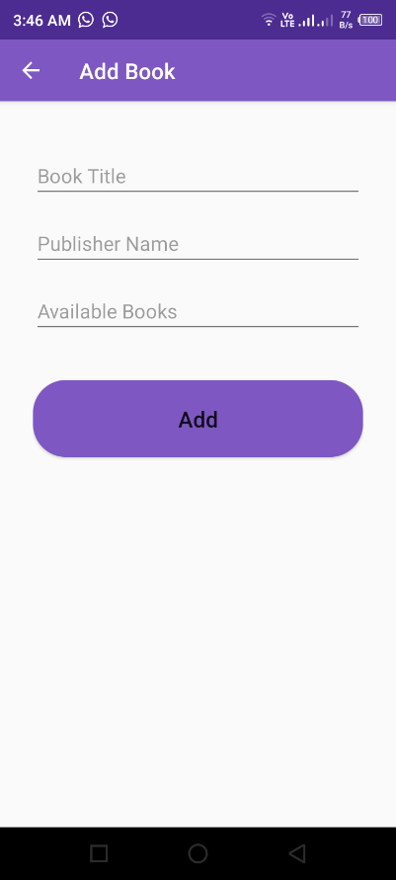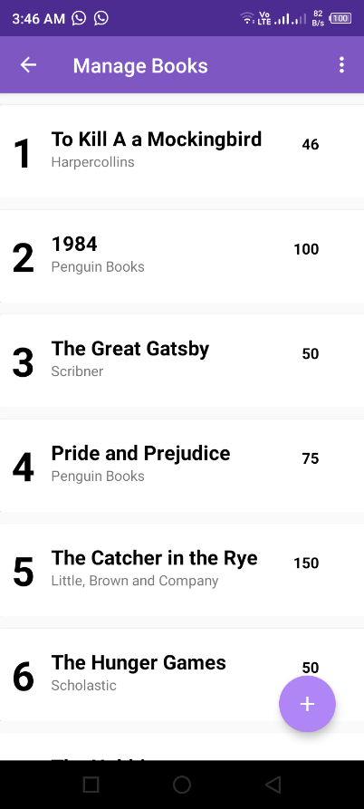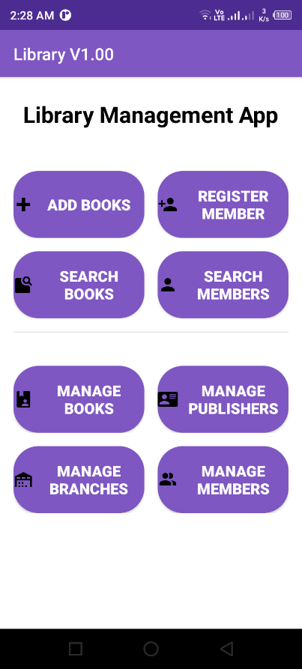

Add Book Page

Manage Book Page

Home Page

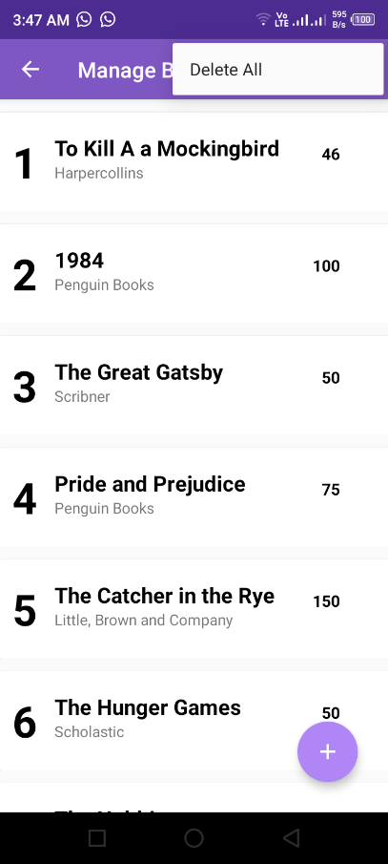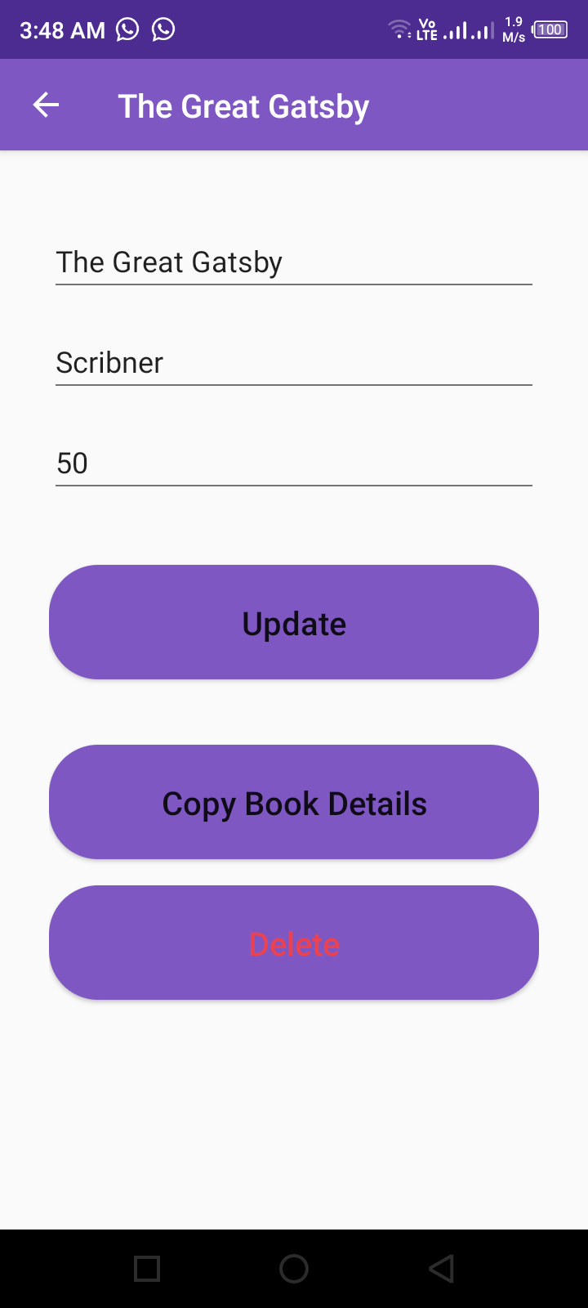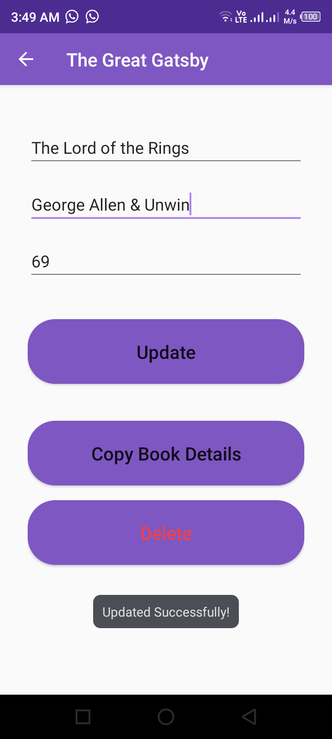

After clicked update button, message show “update successfully”

For Book details update, tap on a book list

Delete All option

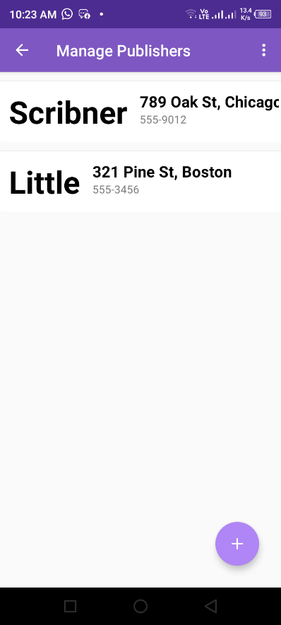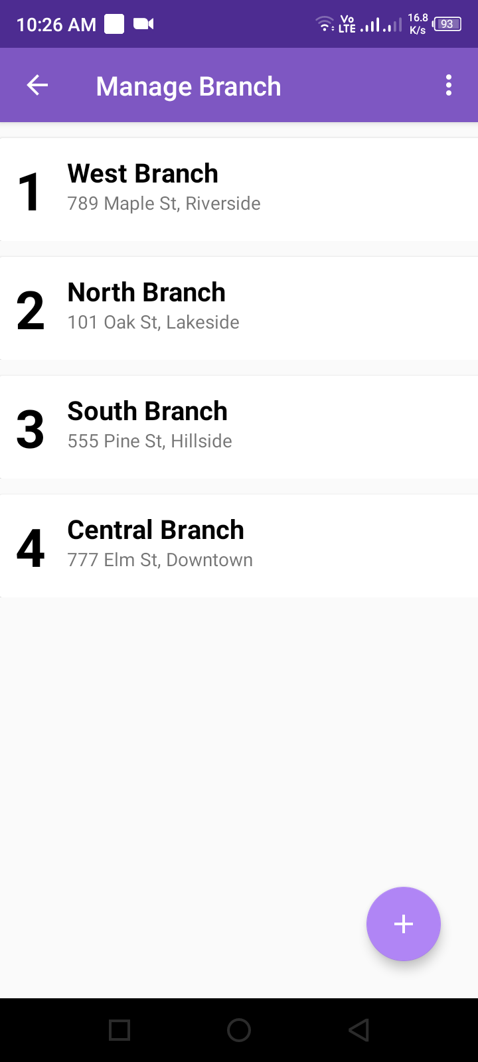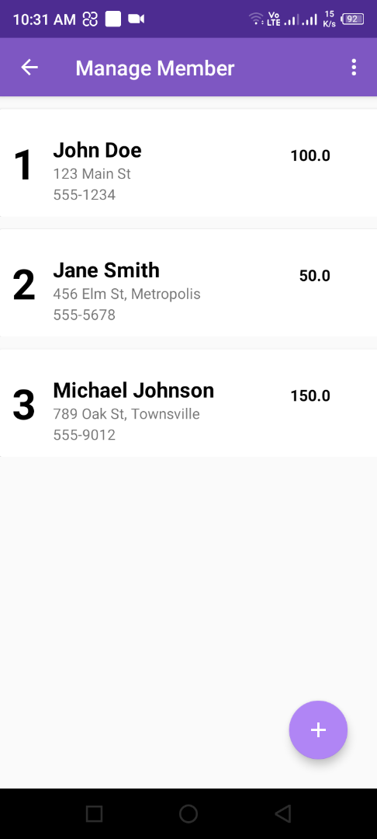

Manage Member page

Manage Branch page

Manage Publisher page

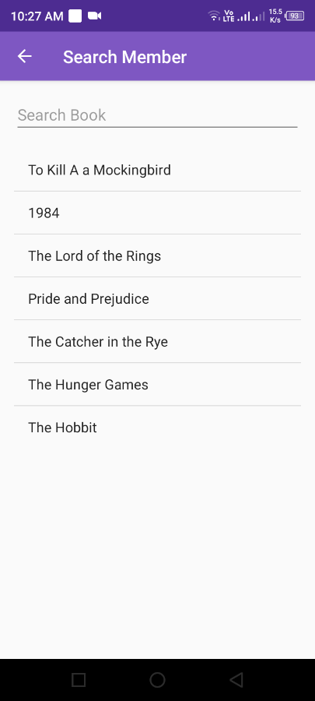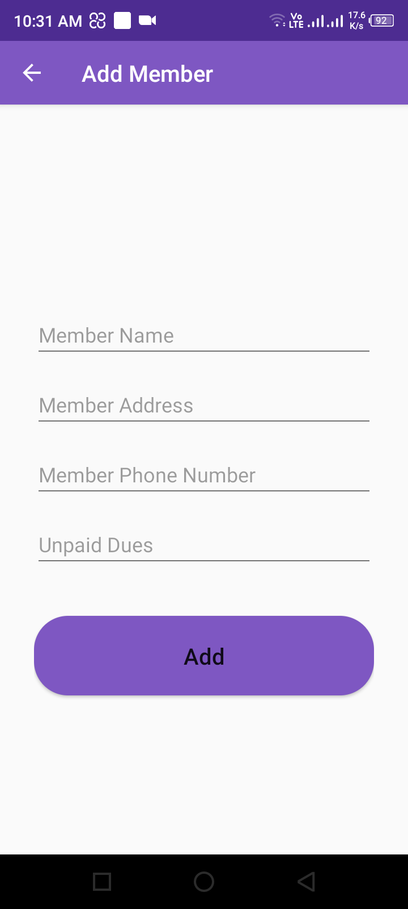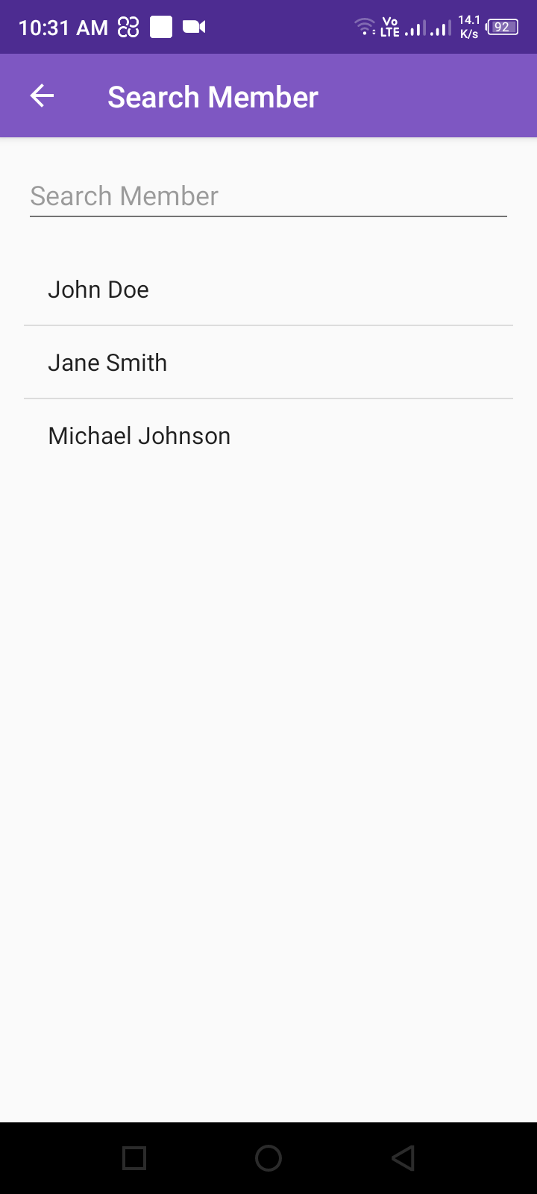

Search Member page

Add Member page

Search Book page

1. **SQLite Screenshots**

